**Assignment 2 :** **Creation of EPIC, User Story, Subtask and Bug in JIRA for a clothing brand SNITCH**

1. **EPIC - HLD and LLD designing for SNITCH**

[**https://nadarjens333.atlassian.net/browse/SCRUM-5**](https://nadarjens333.atlassian.net/browse/SCRUM-5)

* Click on Create

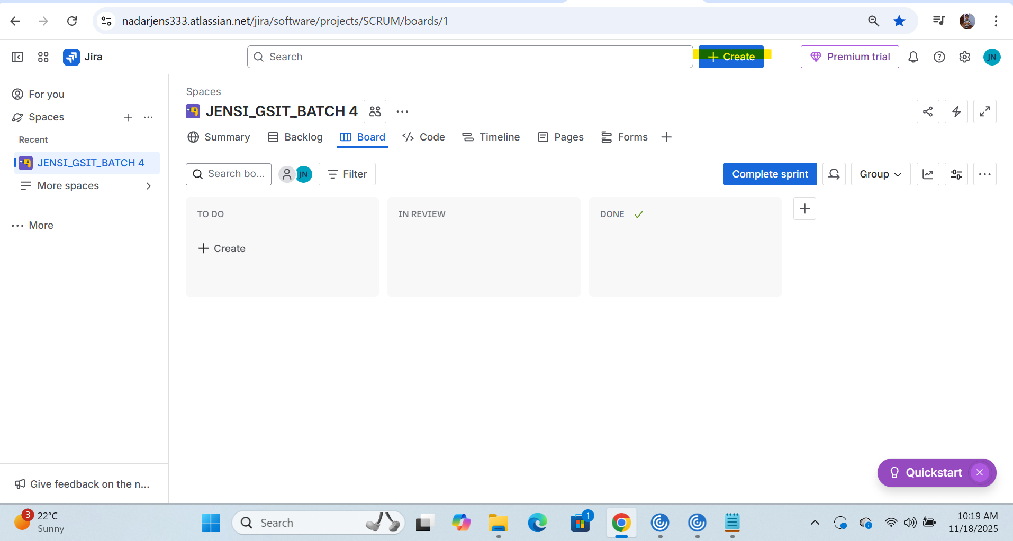

* Select work Type as “EPIC”

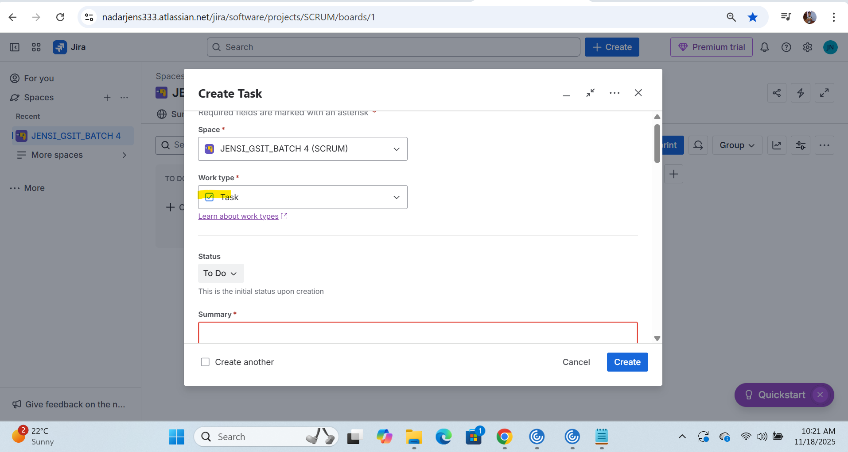

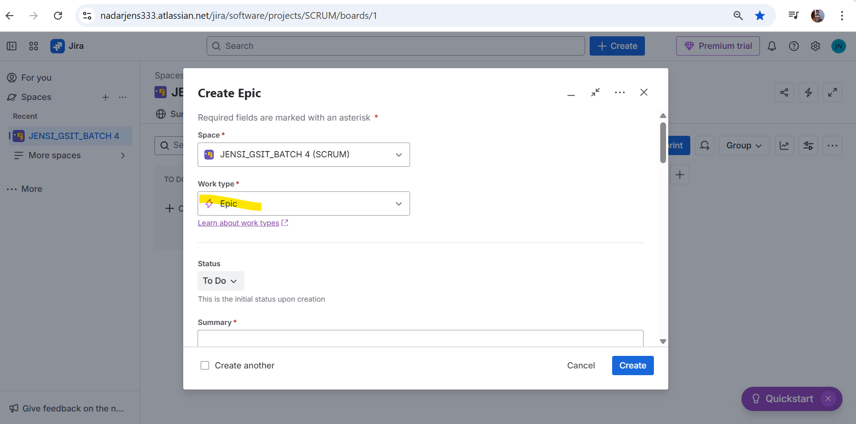

* Input value for field Summary as “**HLD and LLD design of SNITCH”**

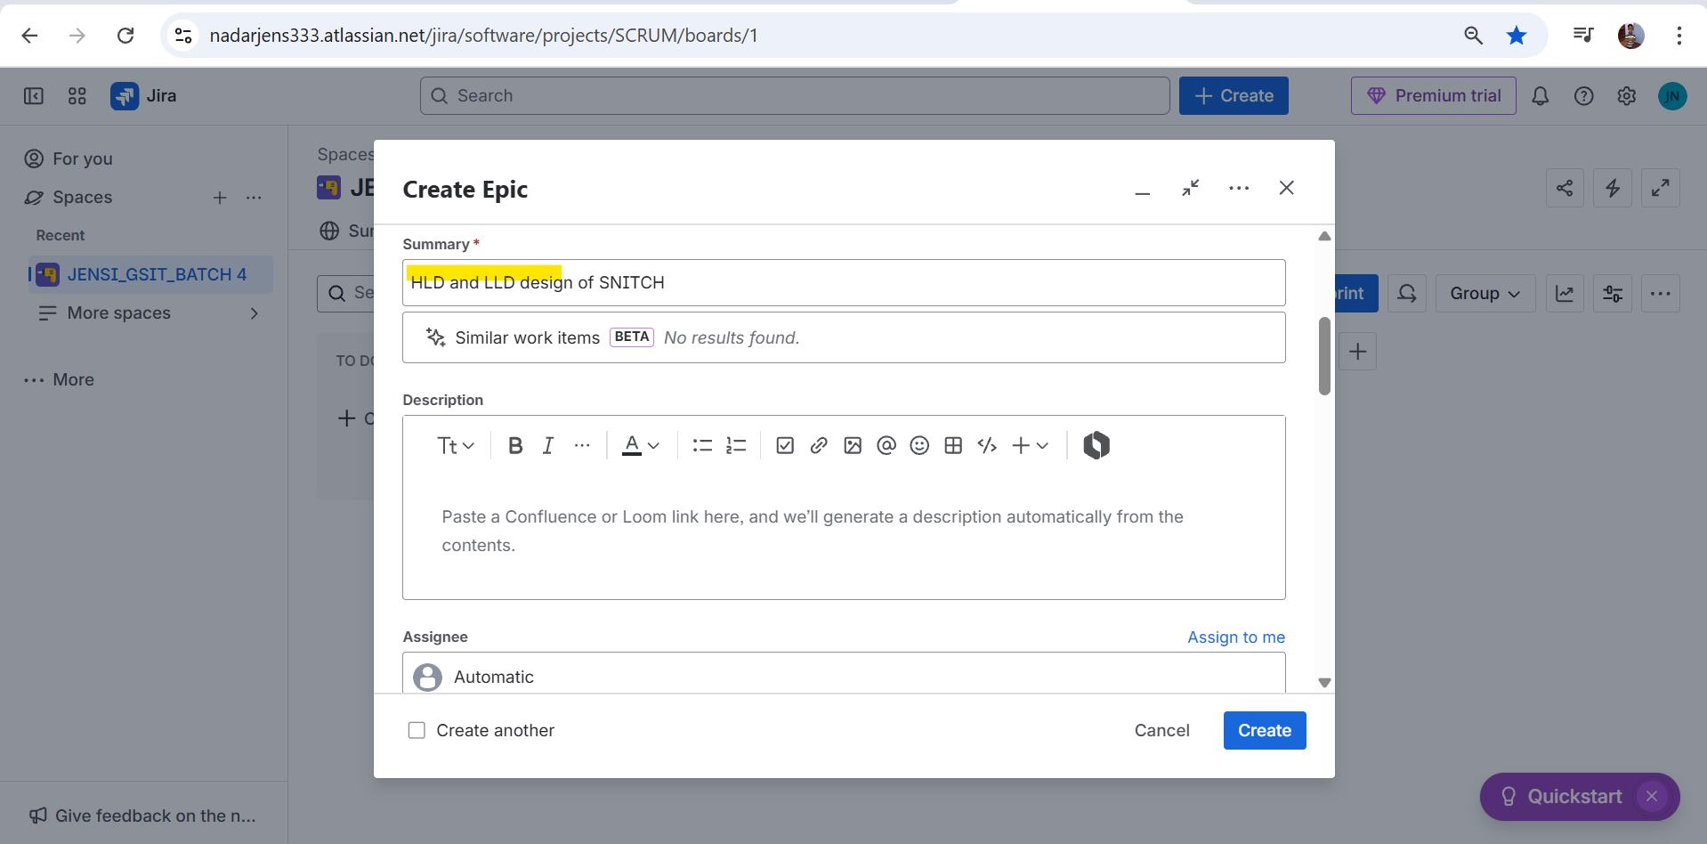

* **Input the Description details**
* 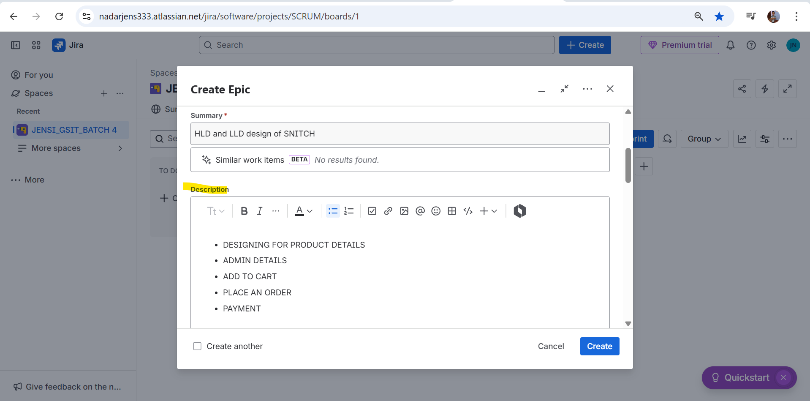
* **Input Label and Assign to yourself**

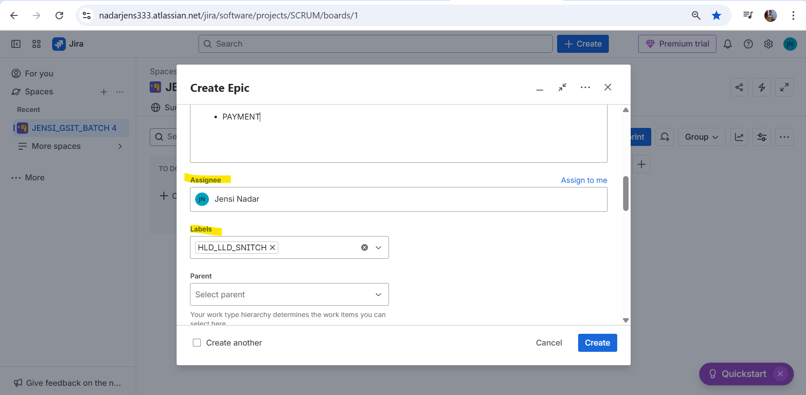

* **Select Start date and Due date**

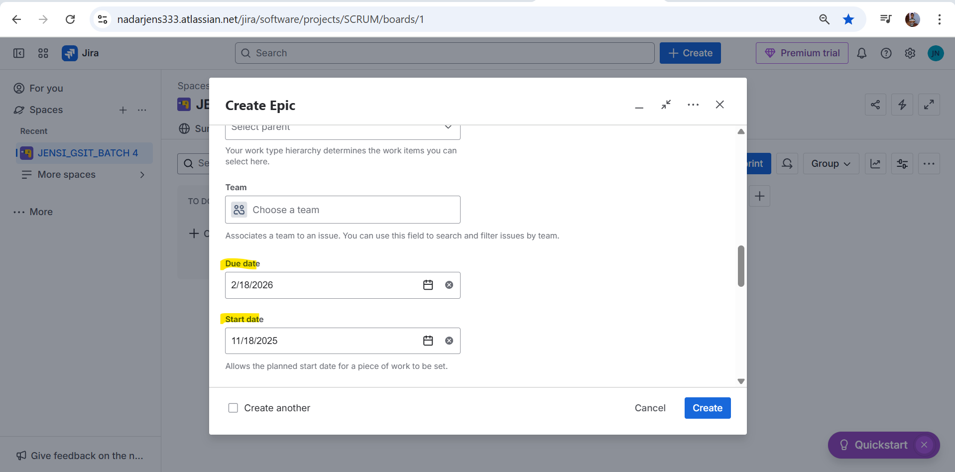

* 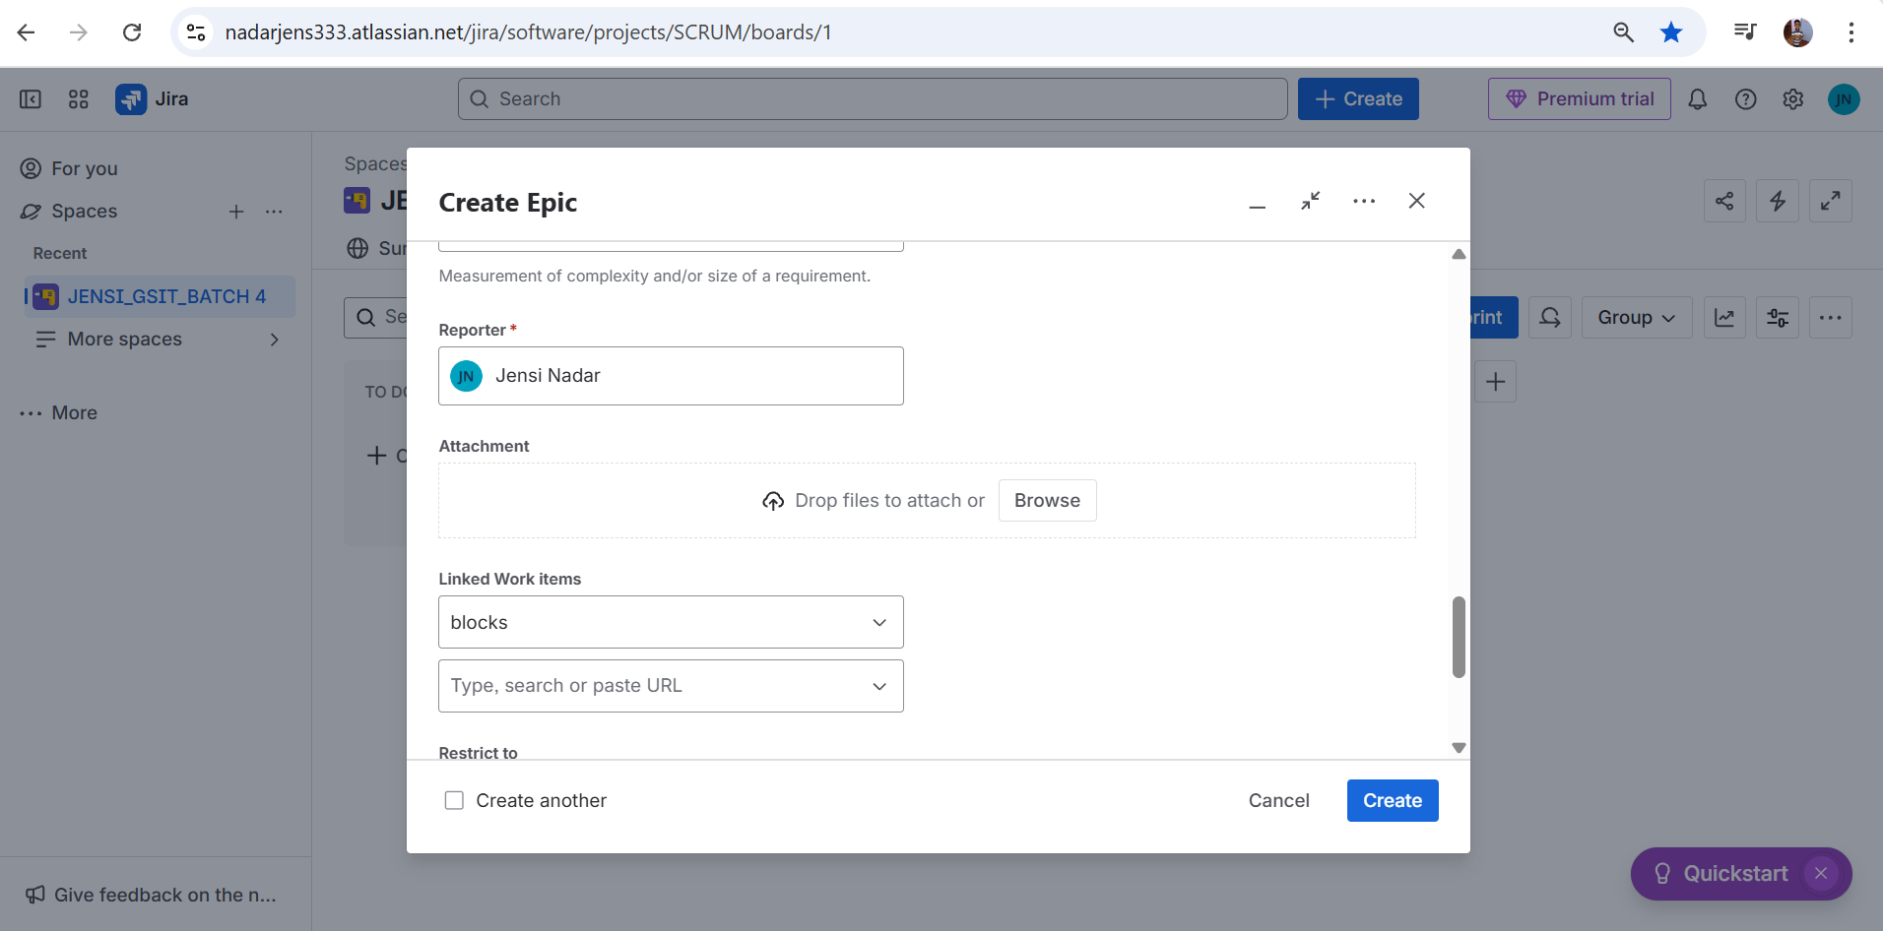

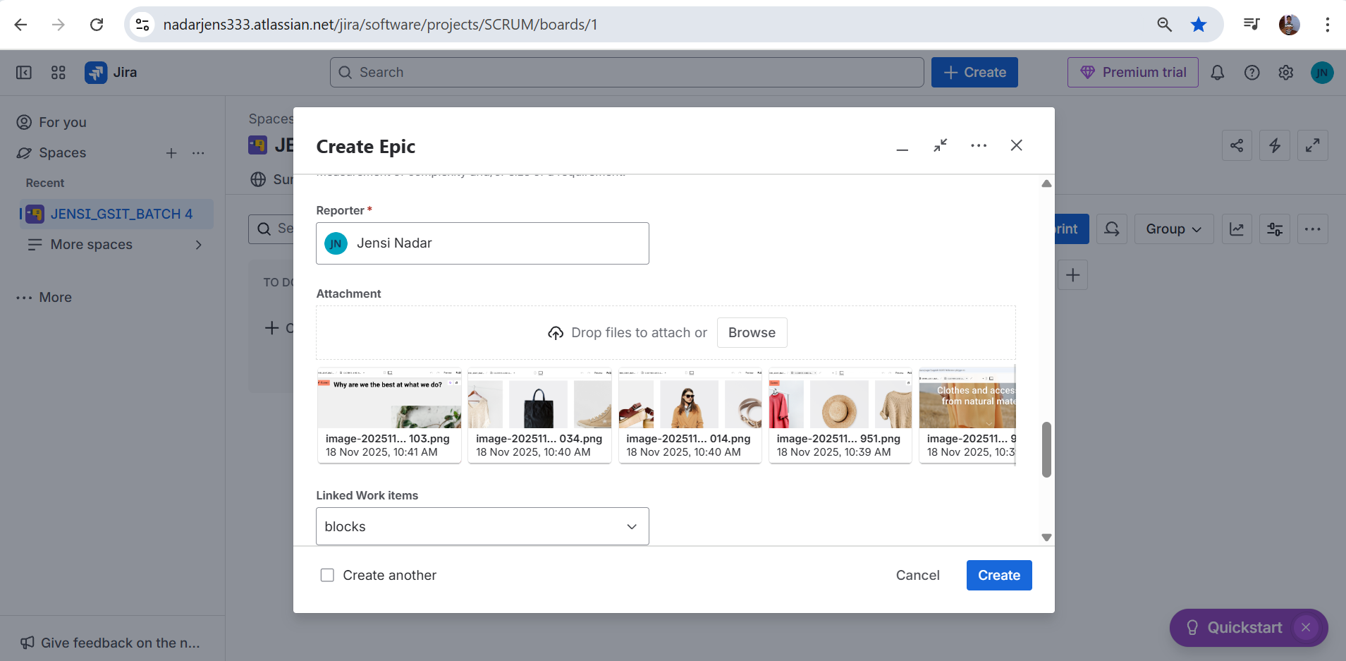

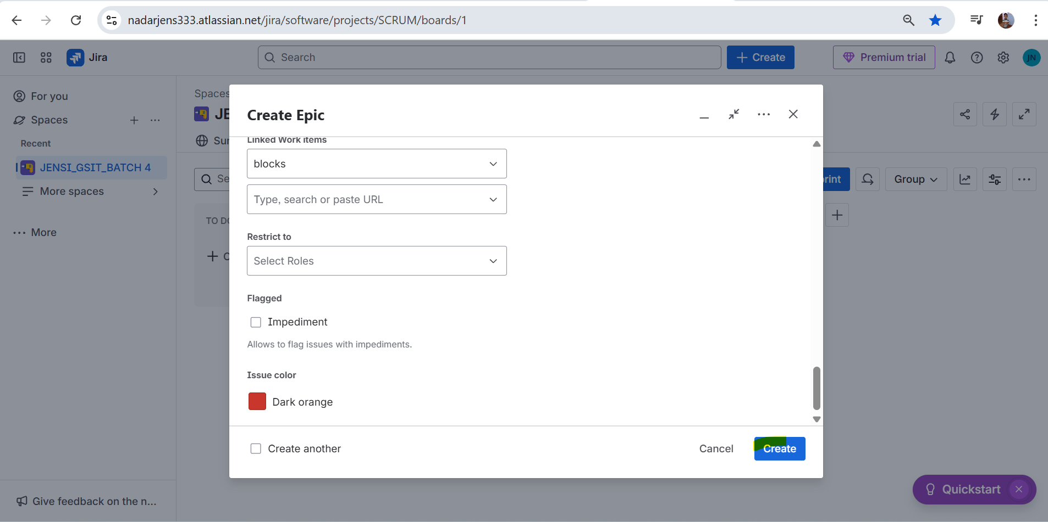

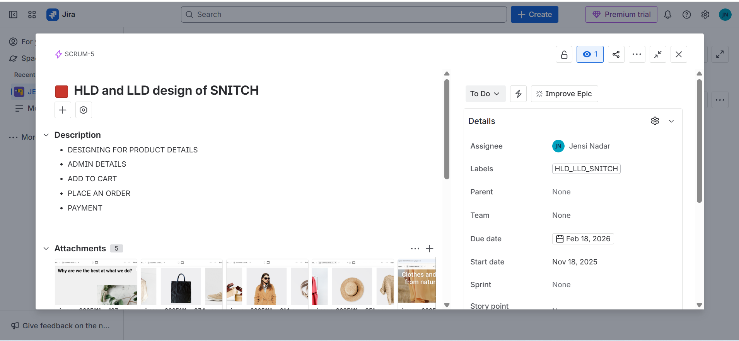

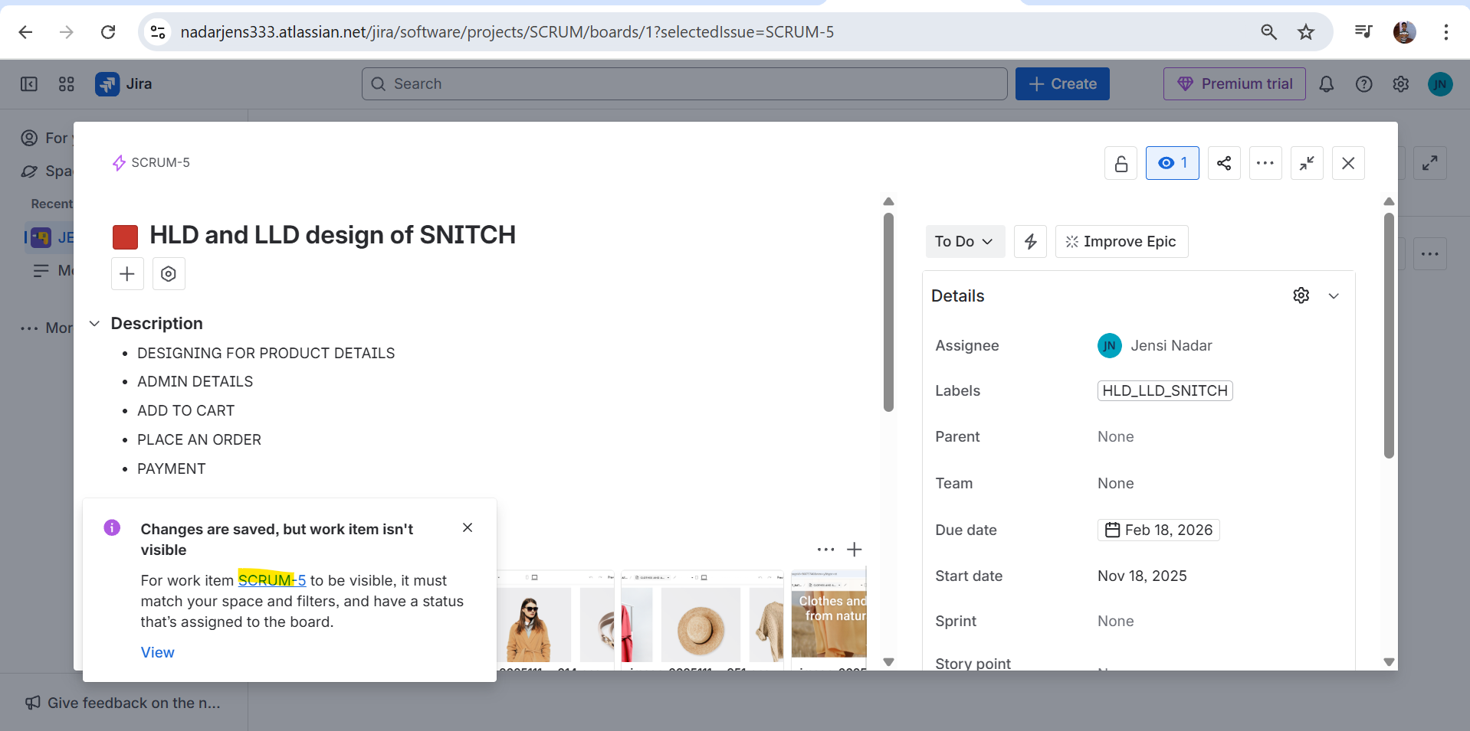

1. **EPIC - DEVELOPMENT for SNITCH**

[**https://nadarjens333.atlassian.net/browse/SCRUM-6**](https://nadarjens333.atlassian.net/browse/SCRUM-6)

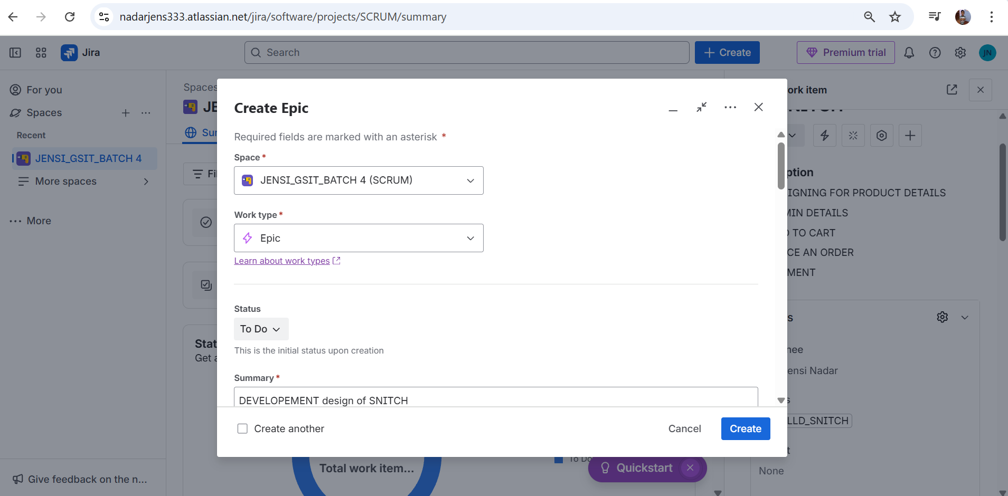

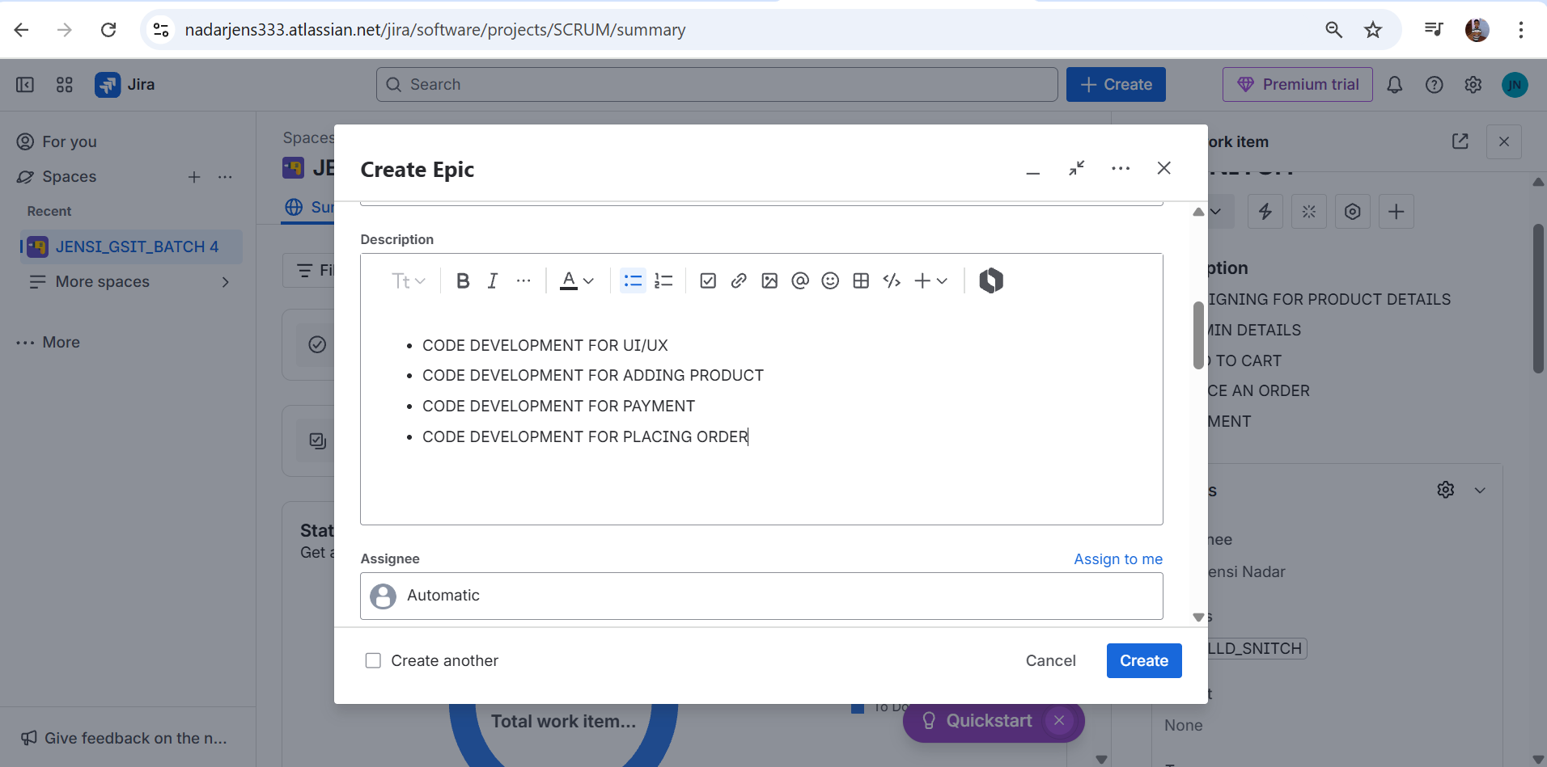

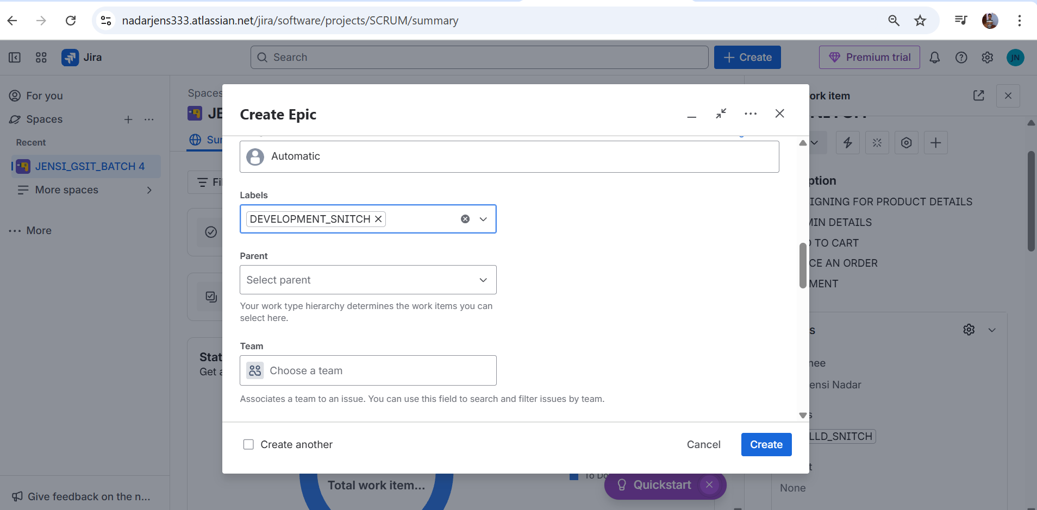

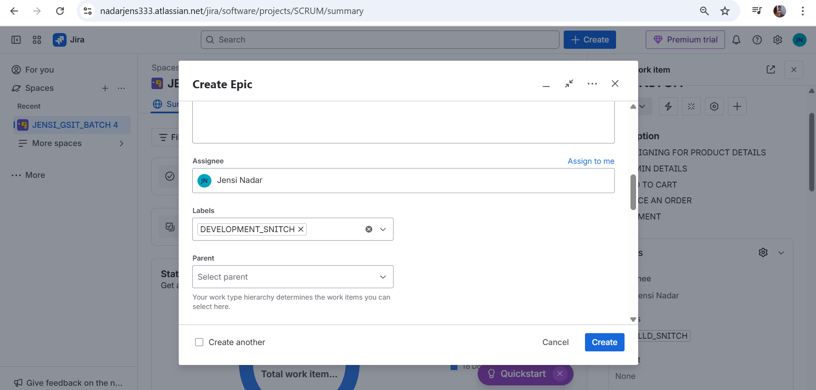

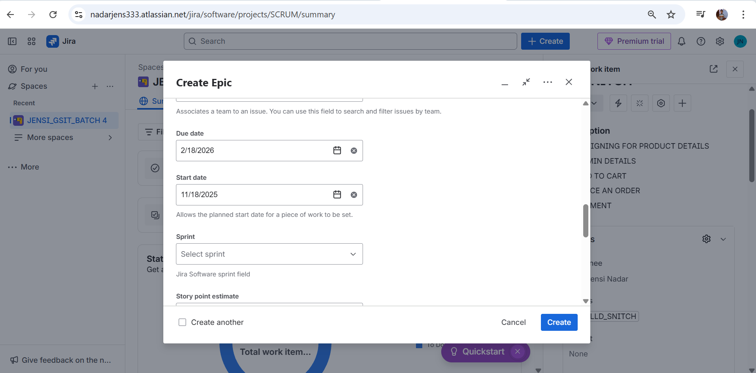

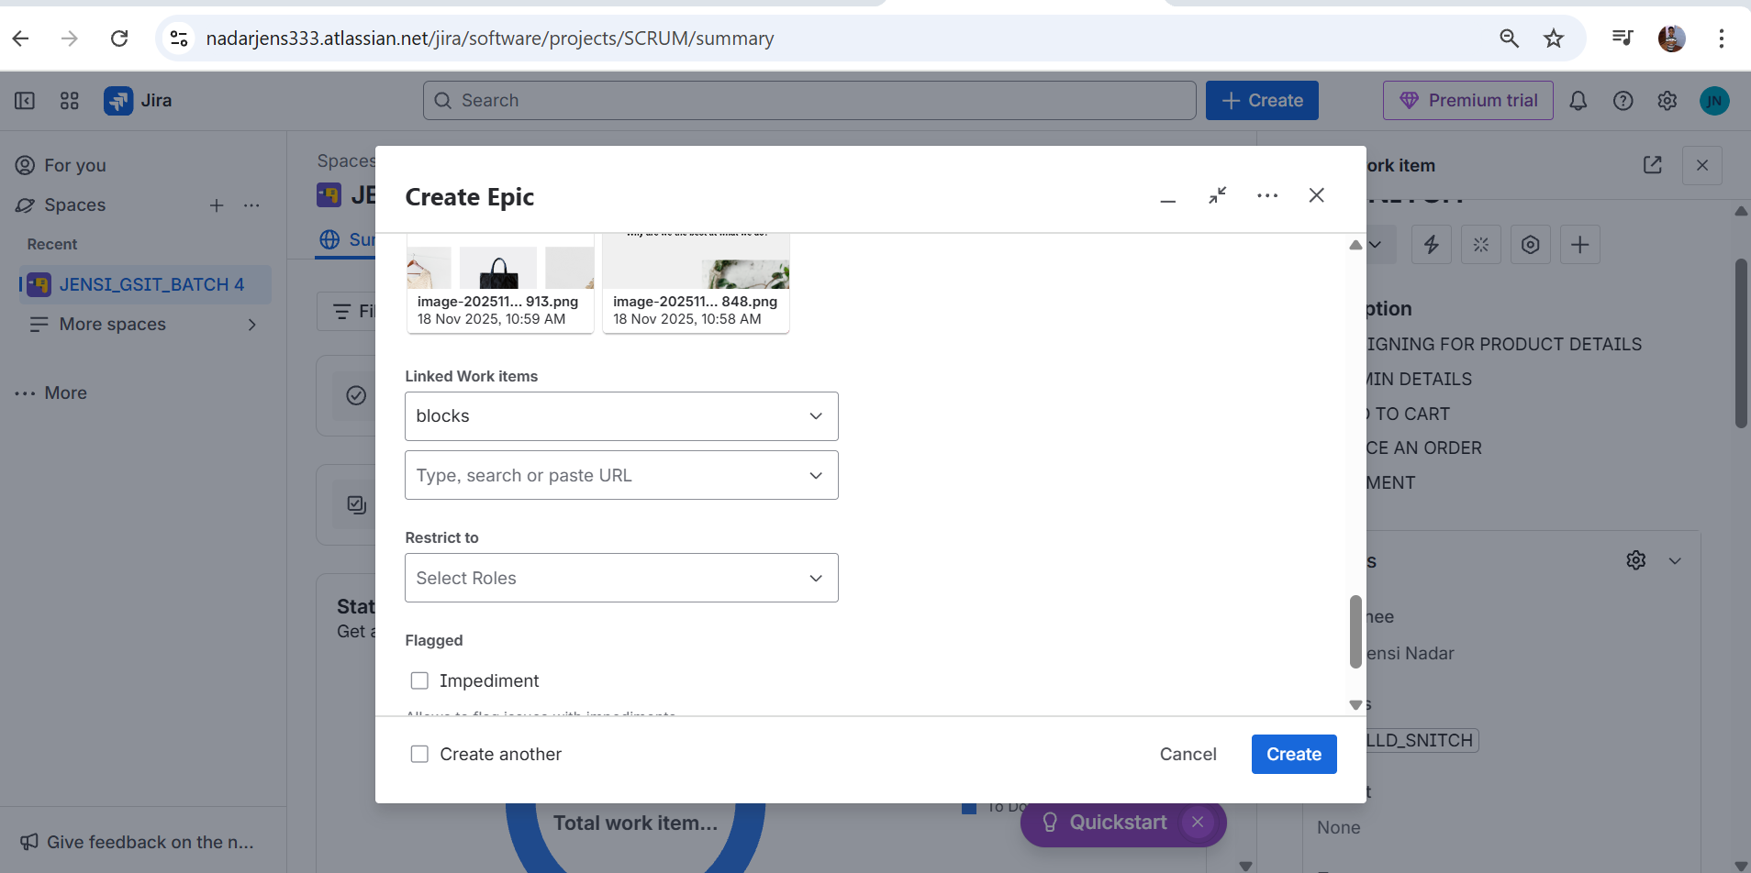

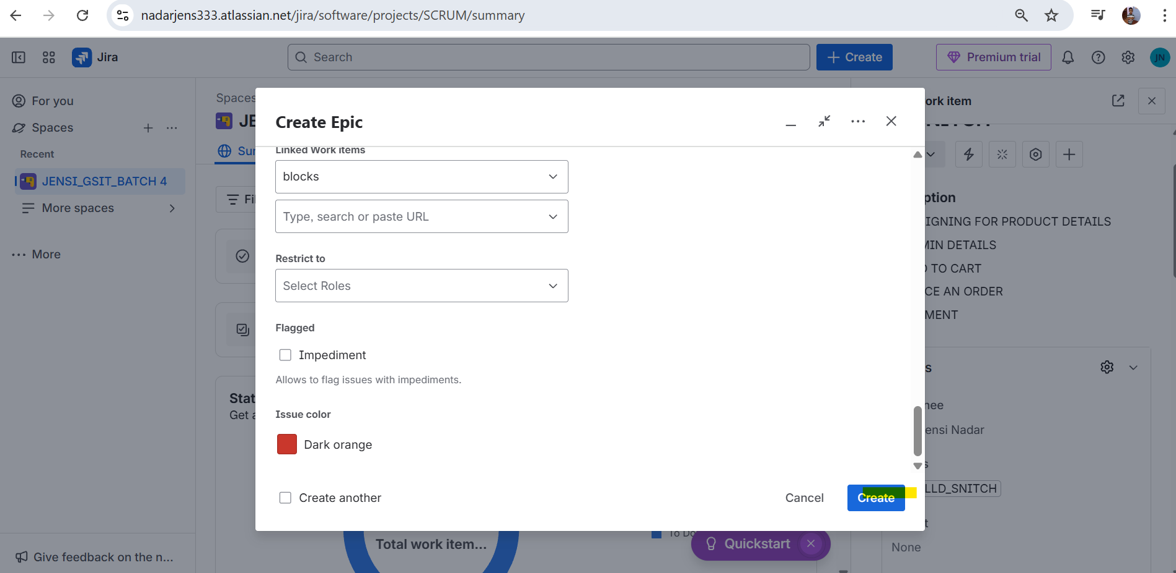

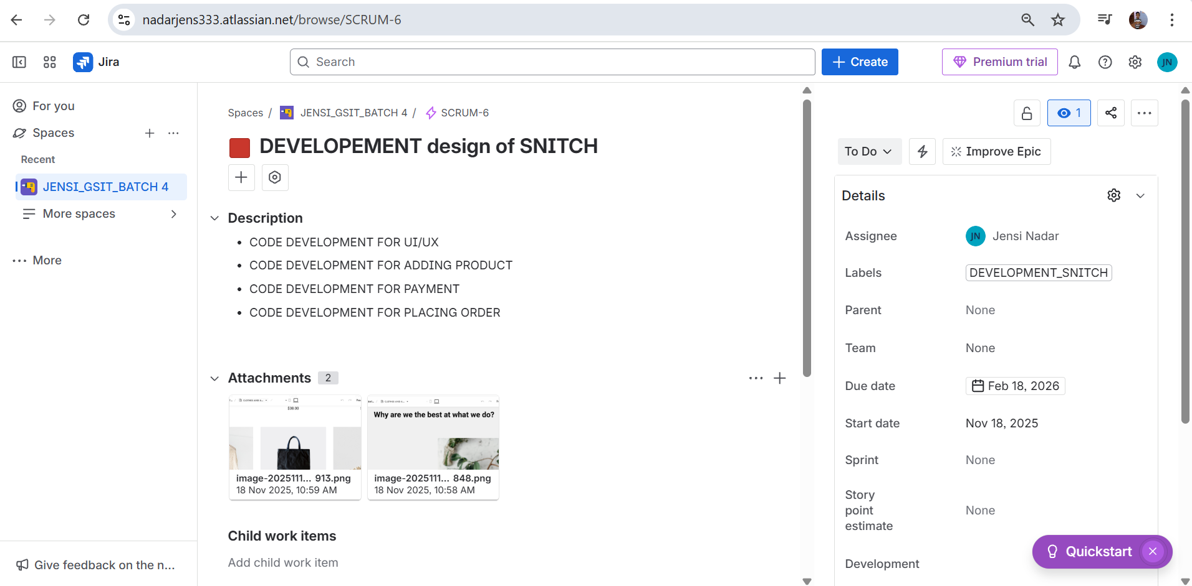

**2. USER STORY CREATION**

[**https://nadarjens333.atlassian.net/browse/SCRUM-7**](https://nadarjens333.atlassian.net/browse/SCRUM-7)

* **Click on + icon**

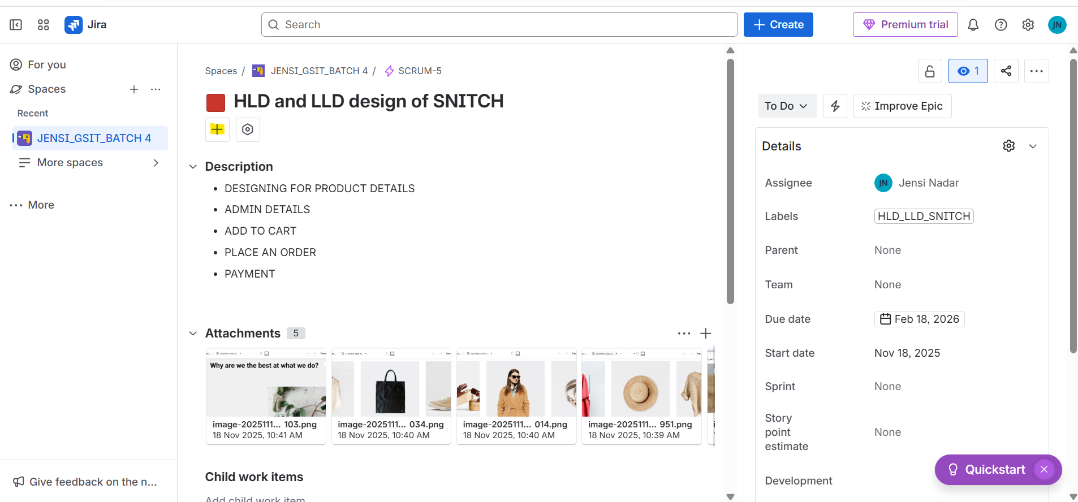

* **Click on create child work item**

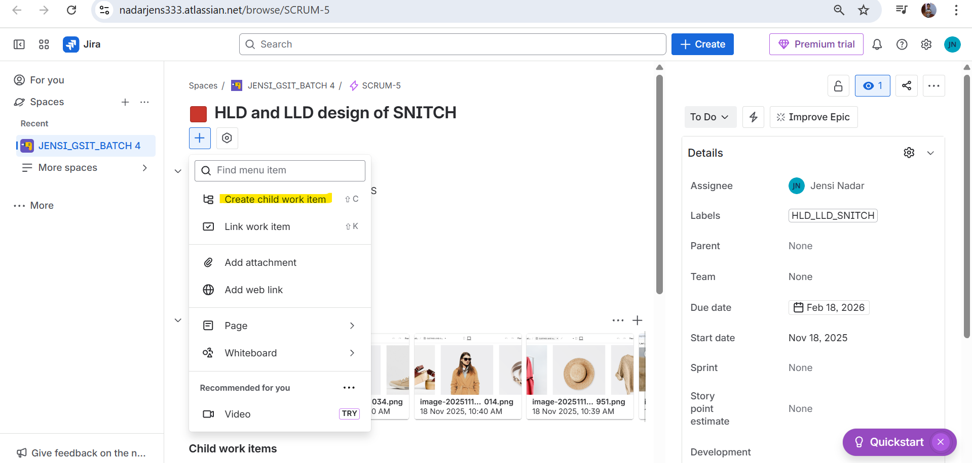

* **Select the type as “Story”**

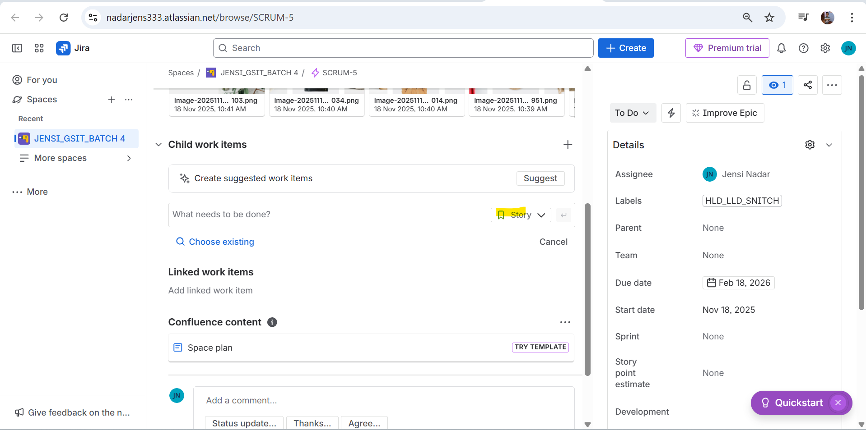

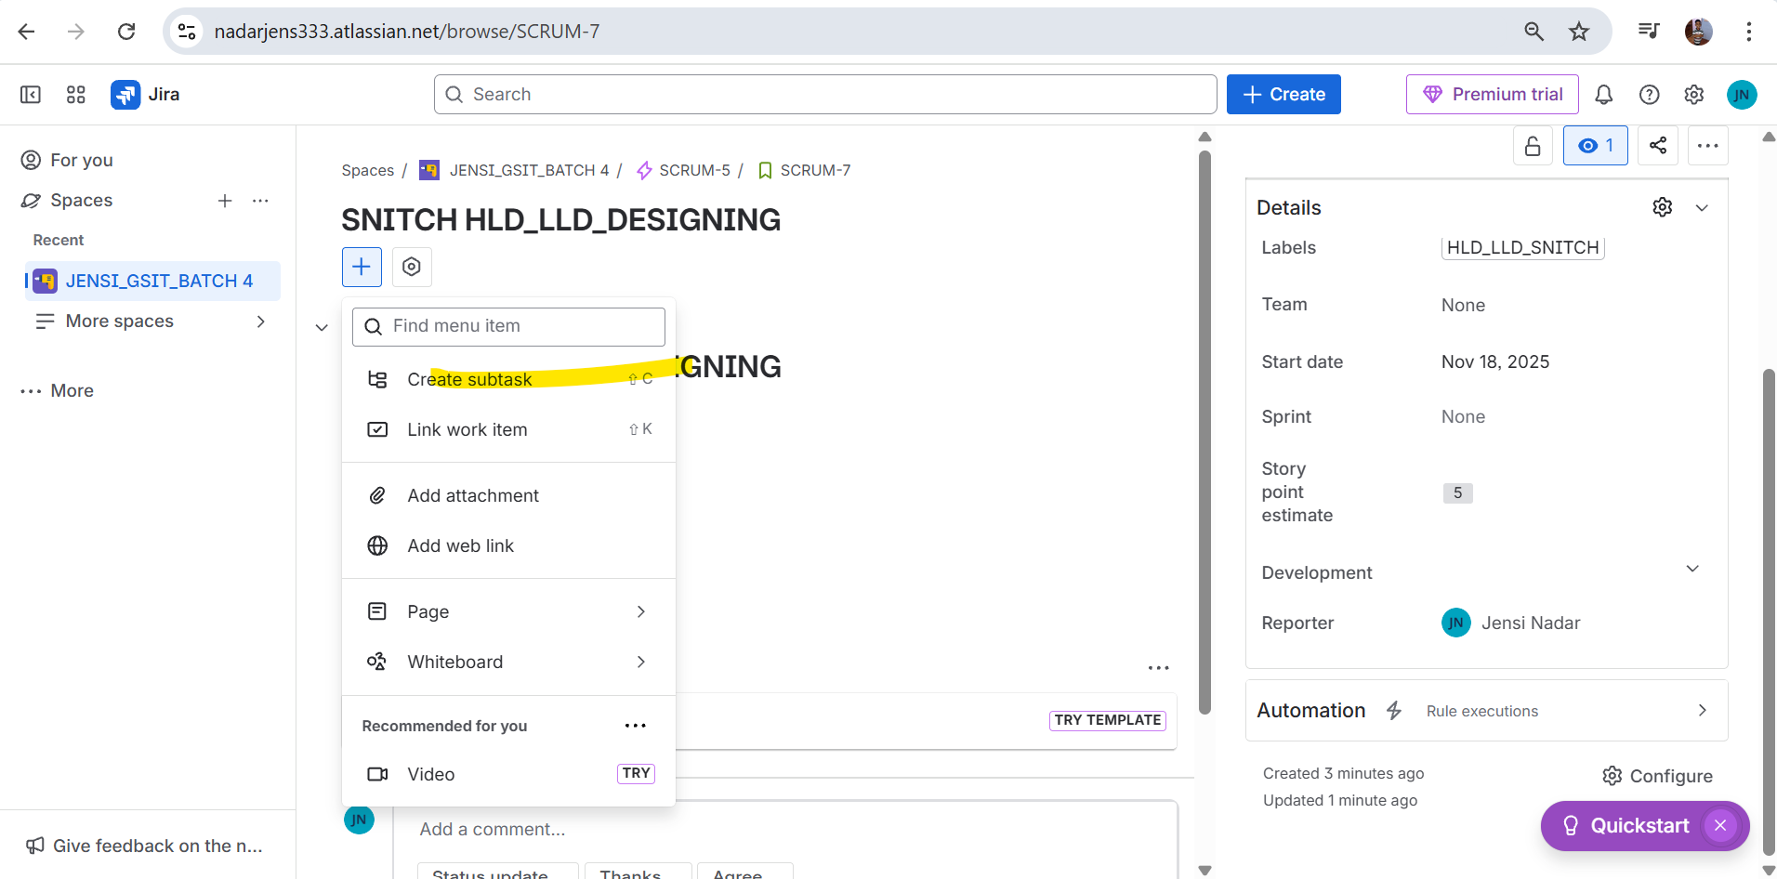

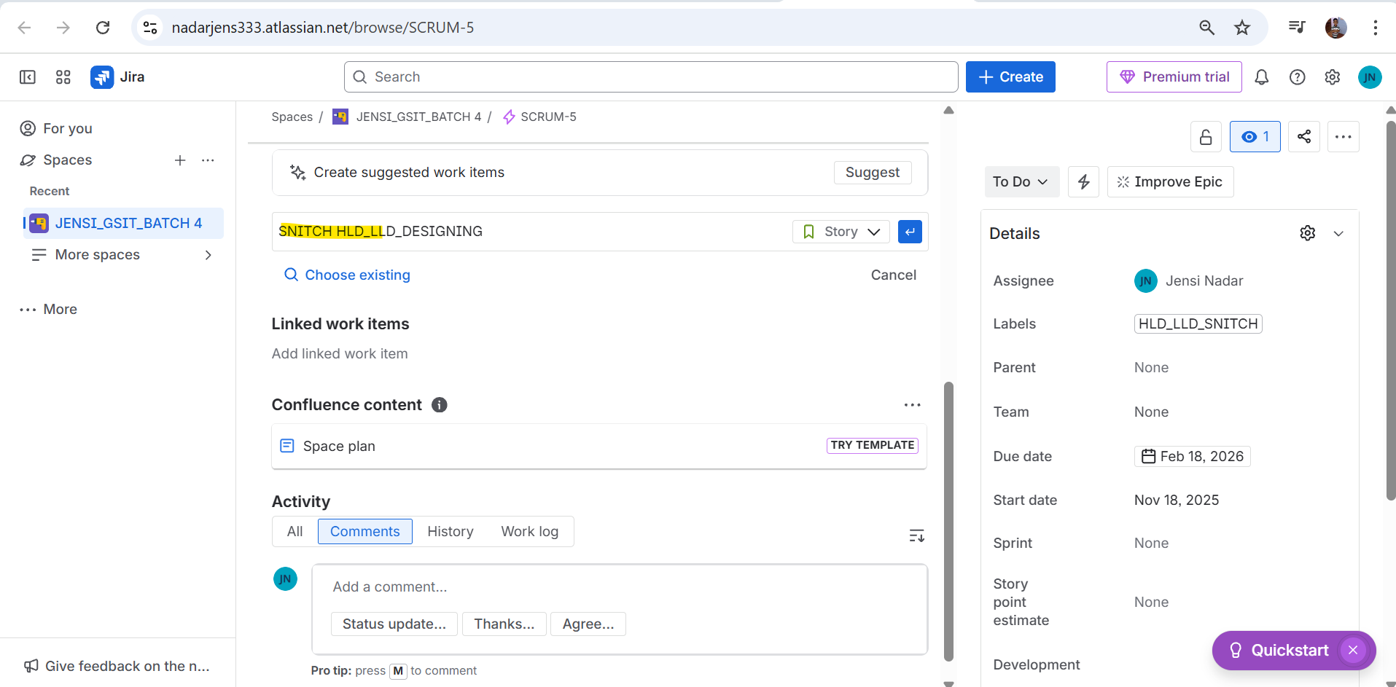

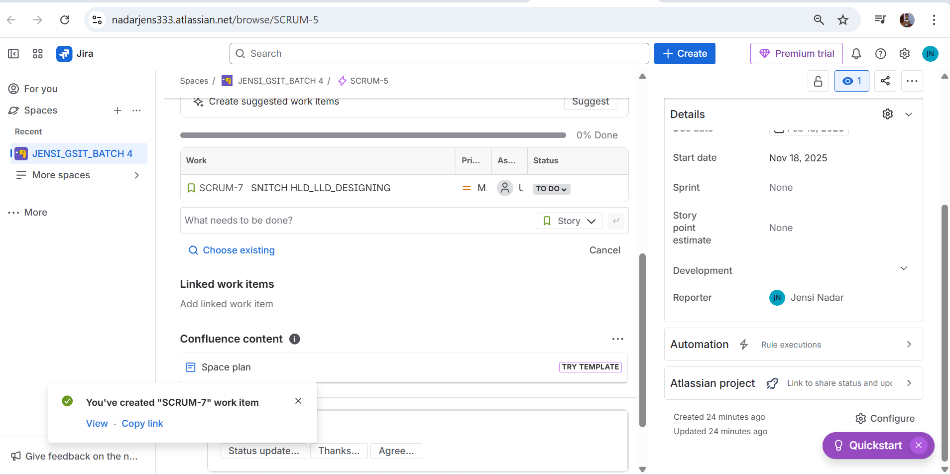

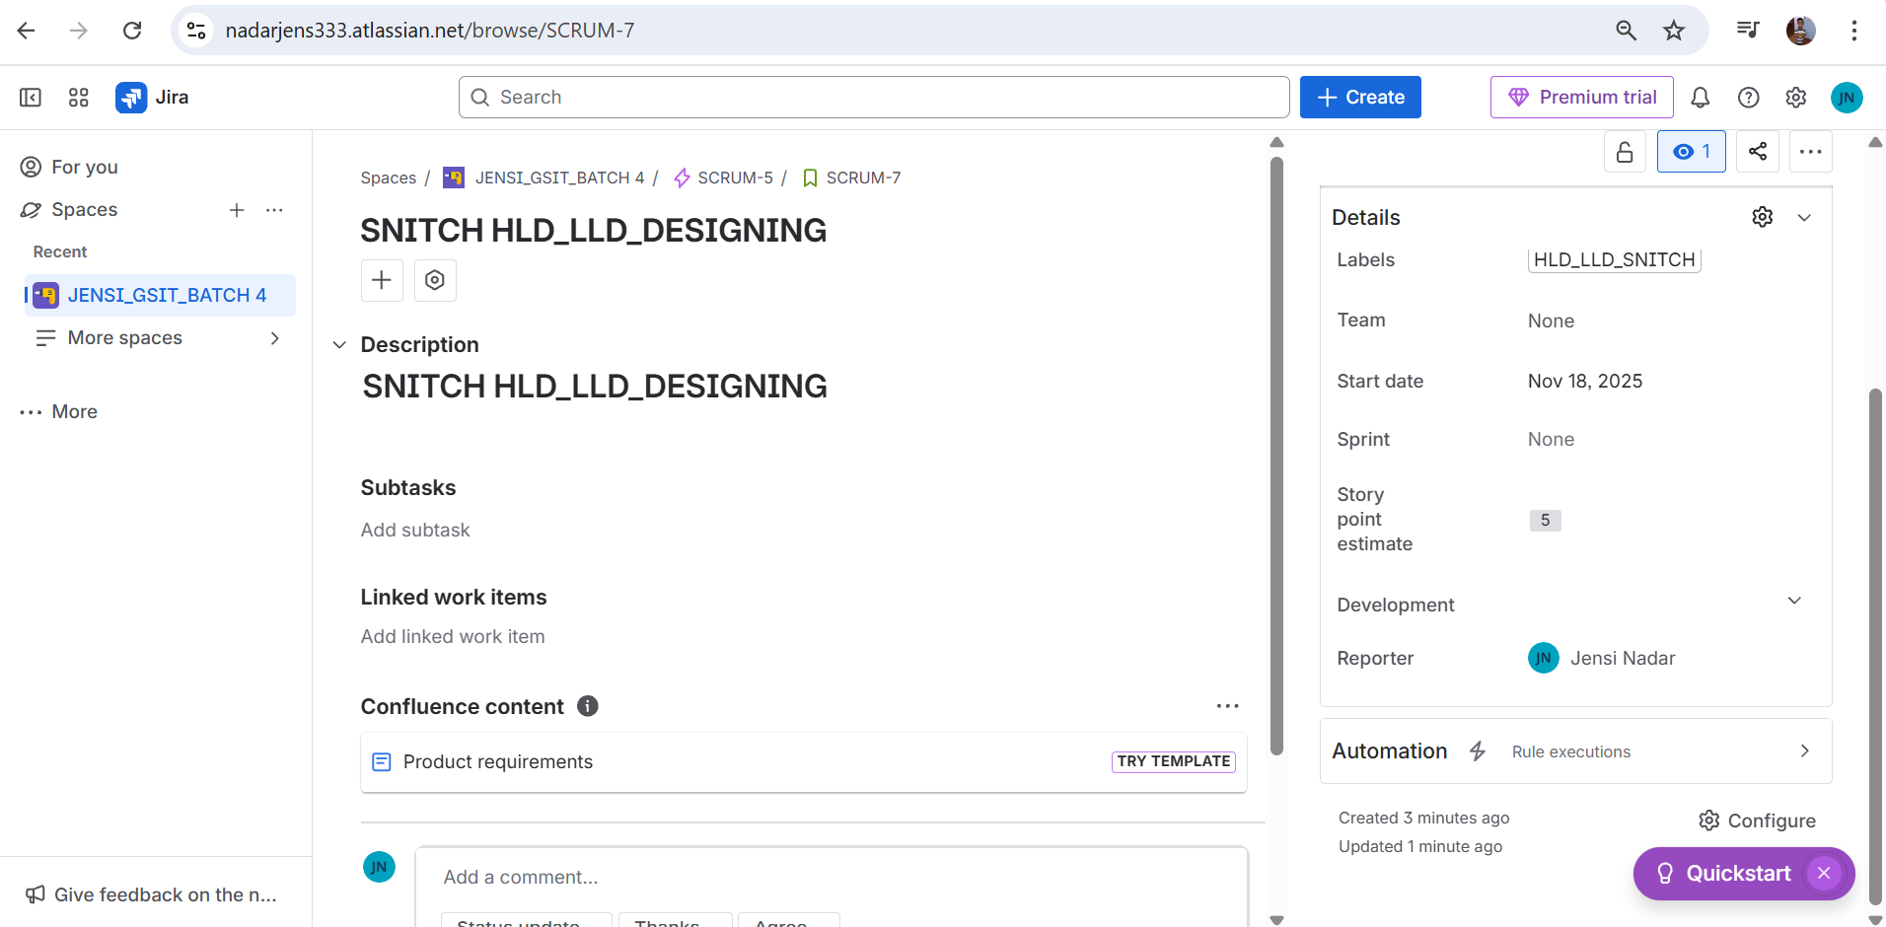

1. **Creation of Task**

[**https://nadarjens333.atlassian.net/browse/SCRUM-8**](https://nadarjens333.atlassian.net/browse/SCRUM-8)

* **Click on create sub-task**

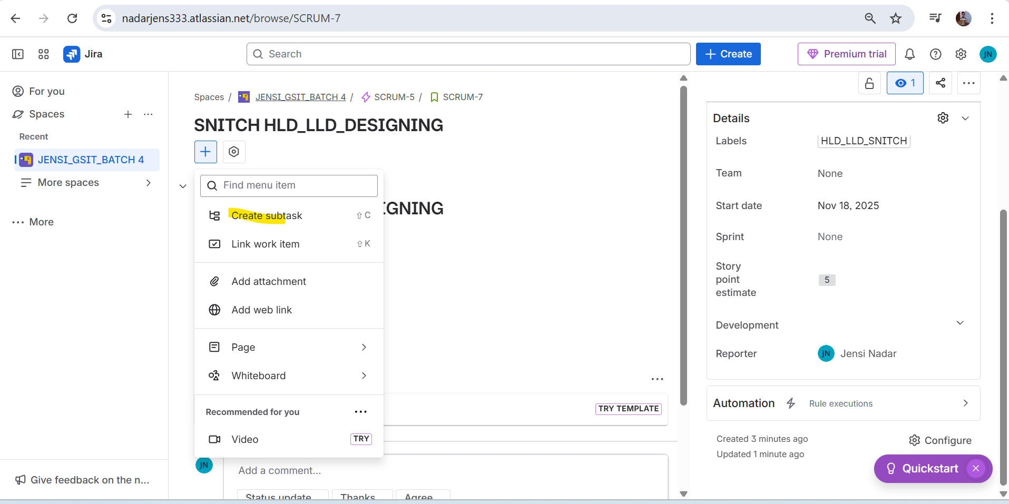

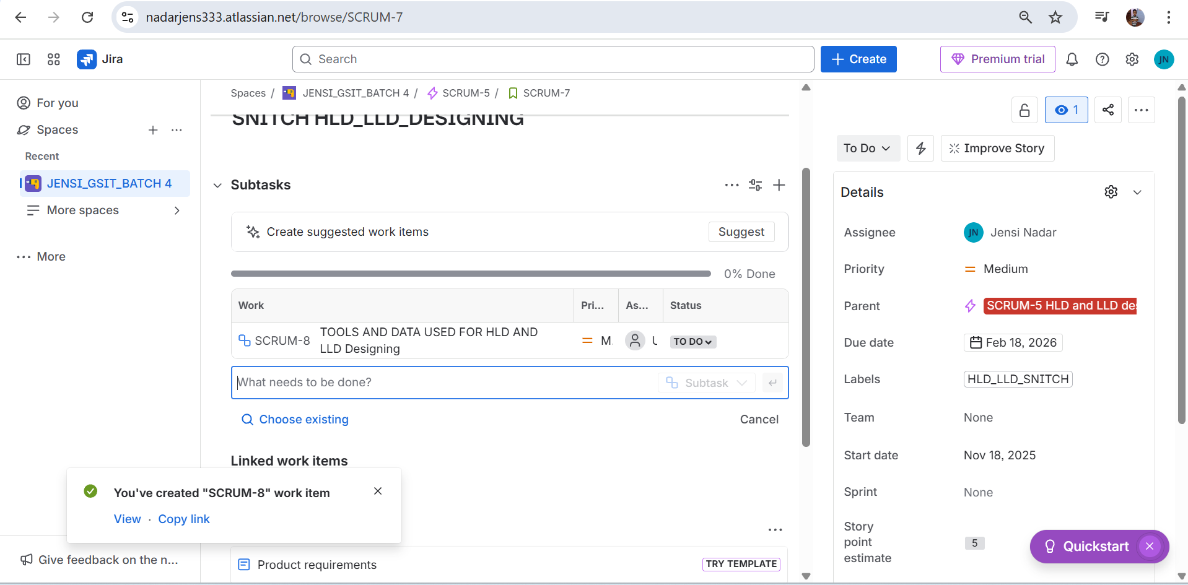

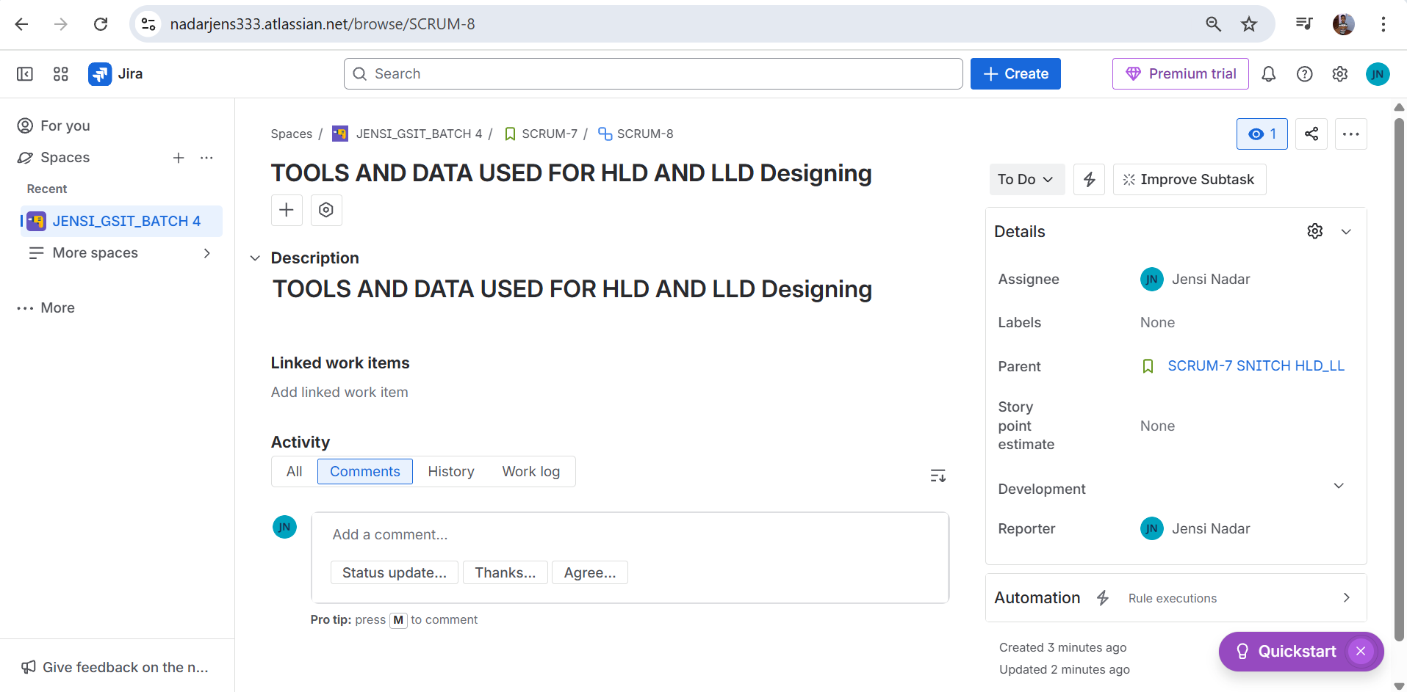

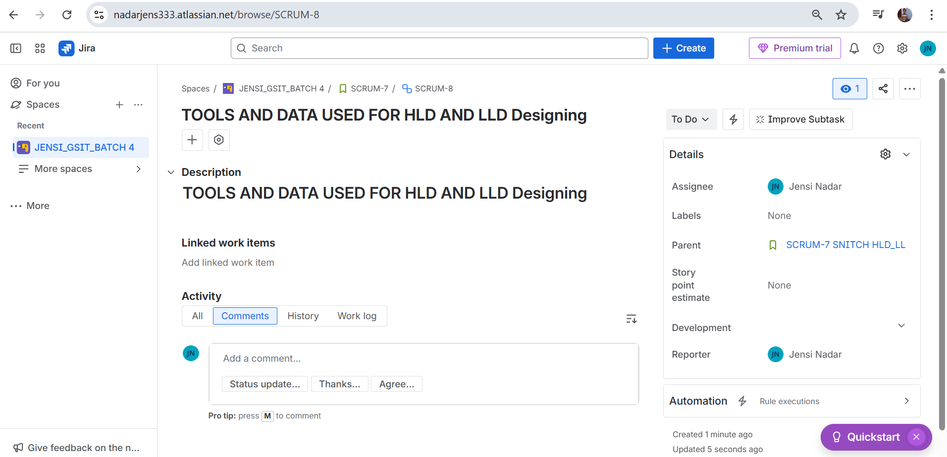

1. **User story creation for EPIC 2 -**

[**https://nadarjens333.atlassian.net/browse/SCRUM-9**](https://nadarjens333.atlassian.net/browse/SCRUM-9)

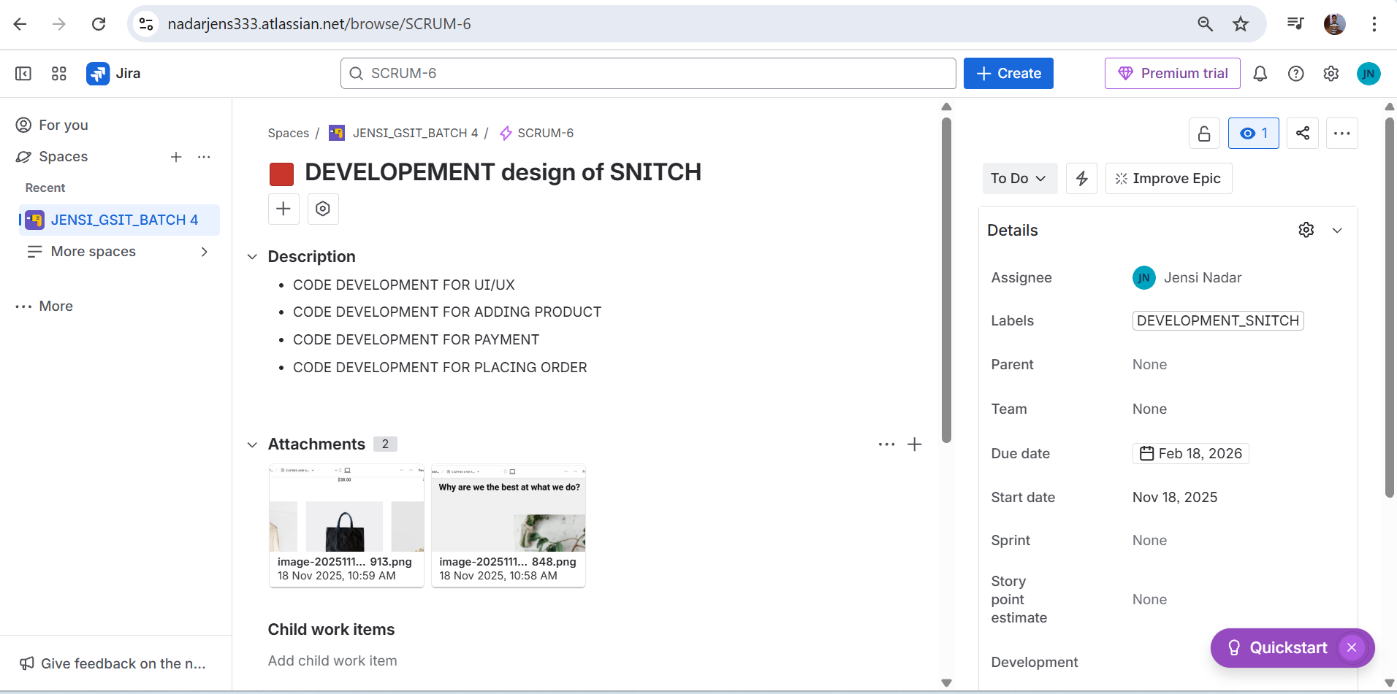

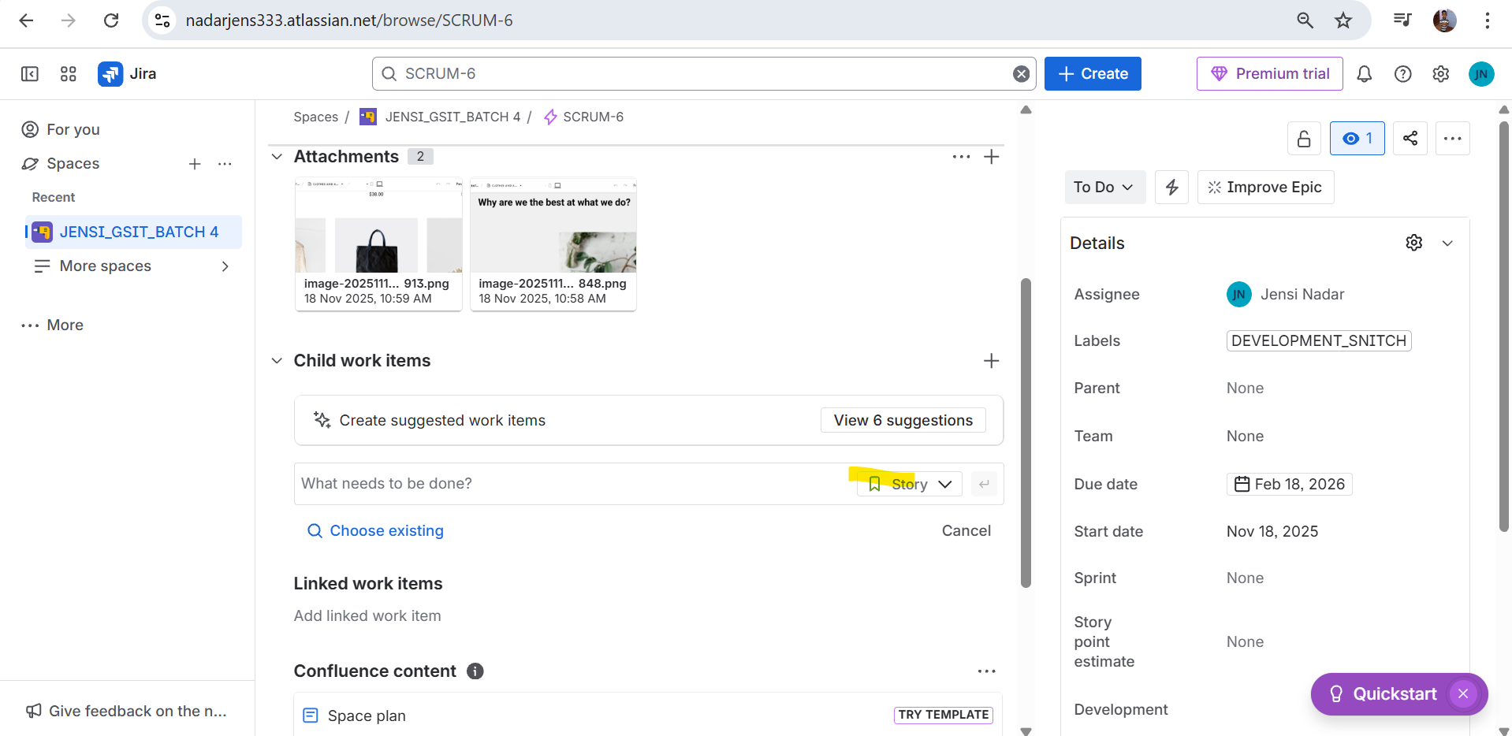

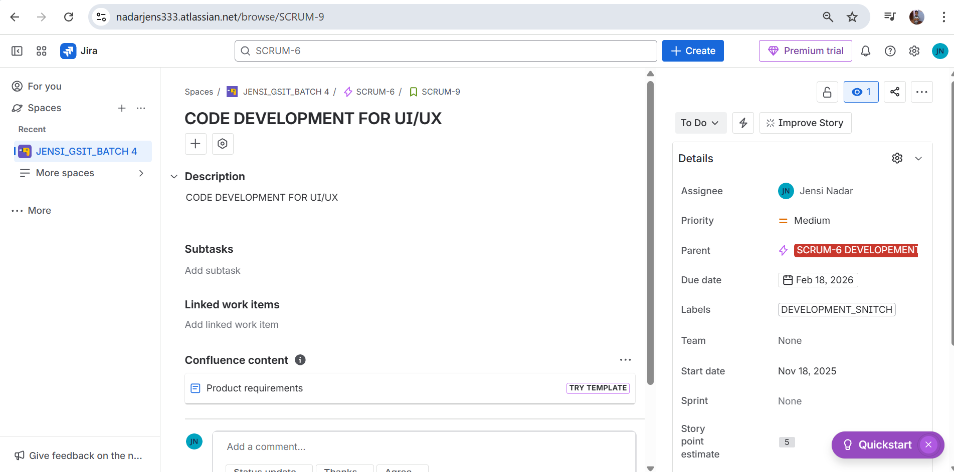

1. **Sub-Task creation for User Story 2 - DEVELOPMENT**

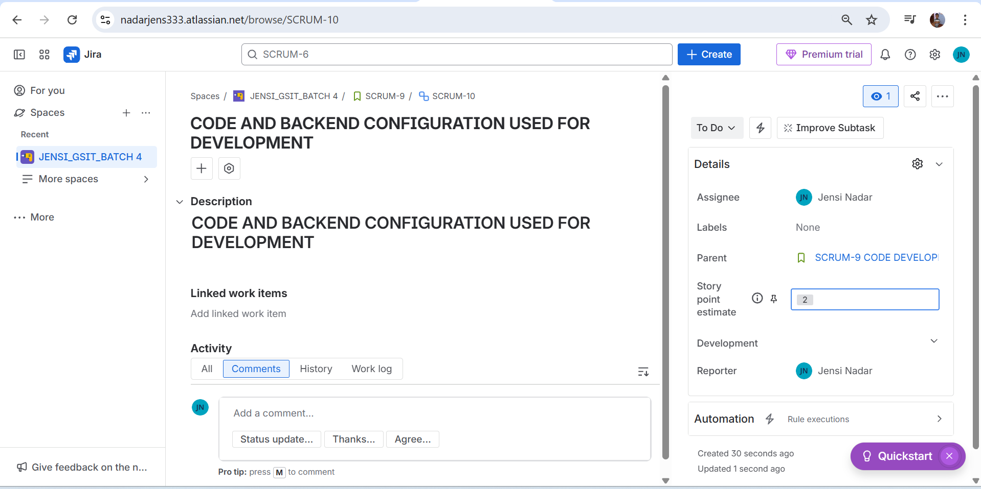

1. **Moving Sprint from Product Backlog**

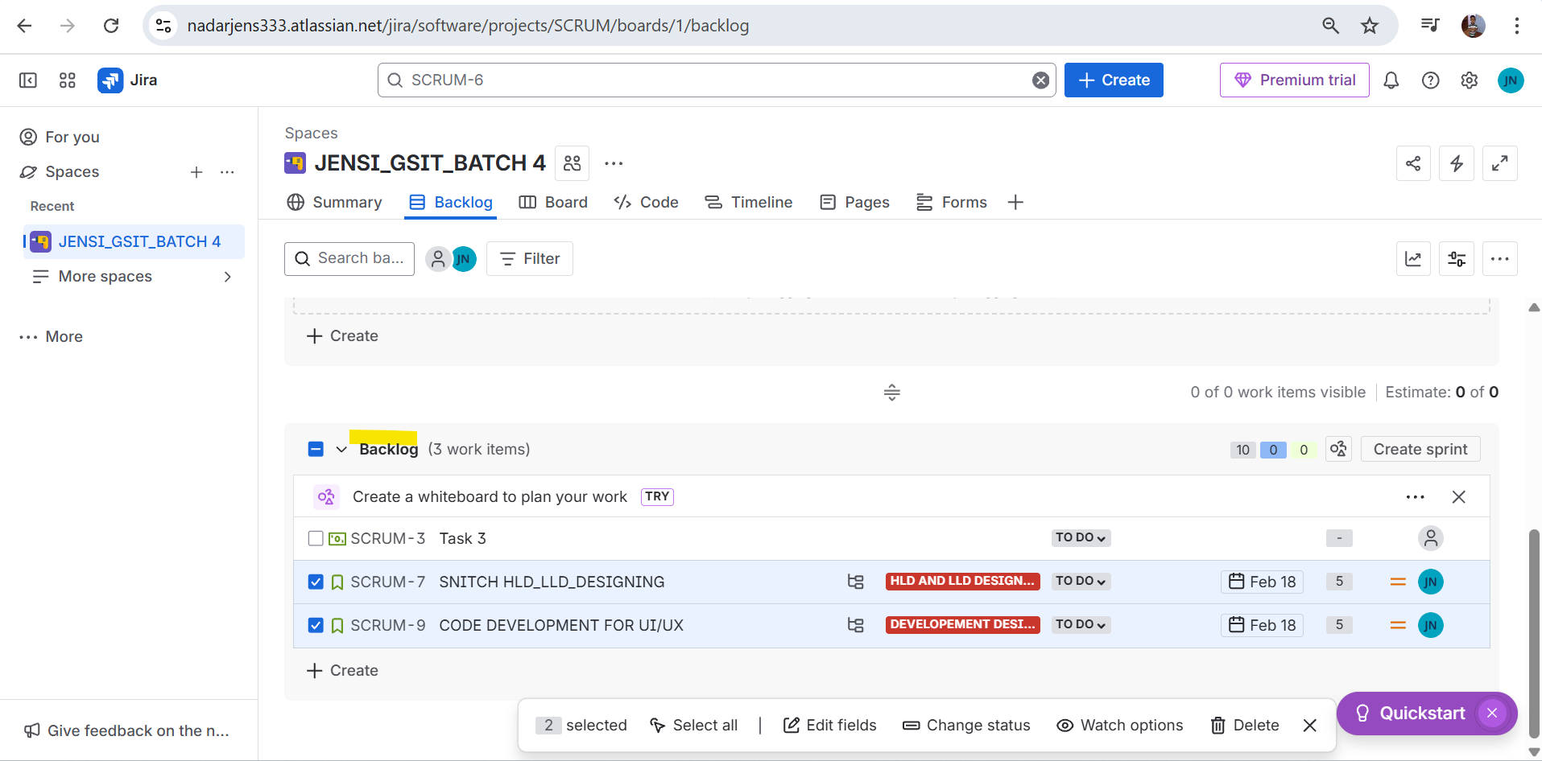

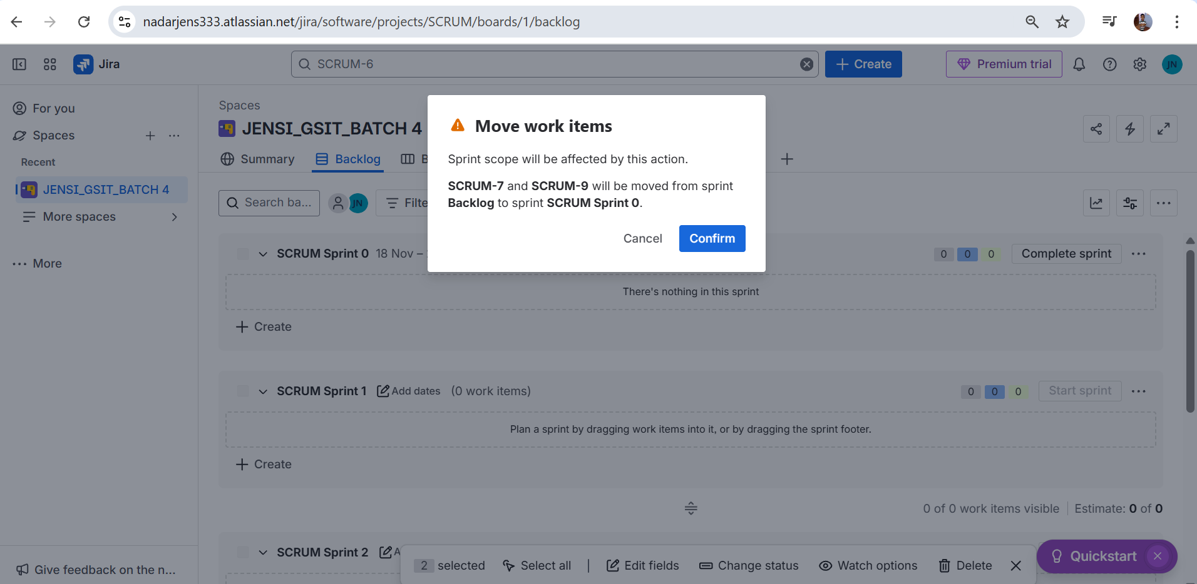

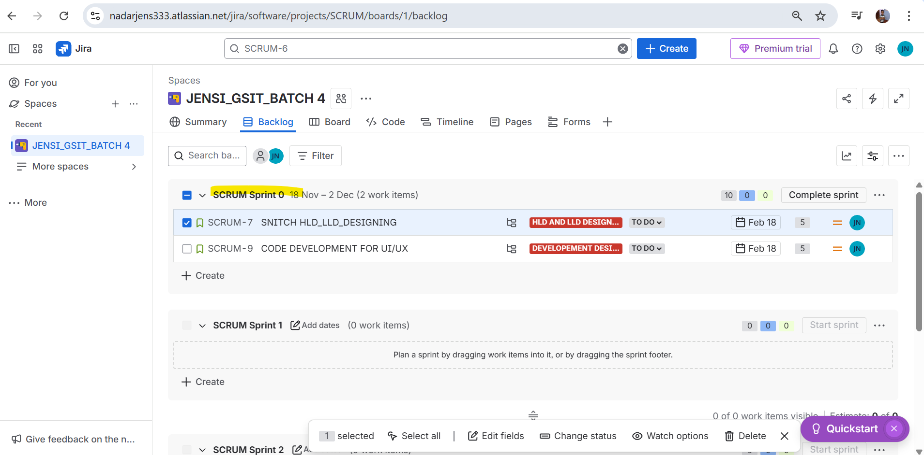

1. **Moving Task from To-Do to In-Progress**

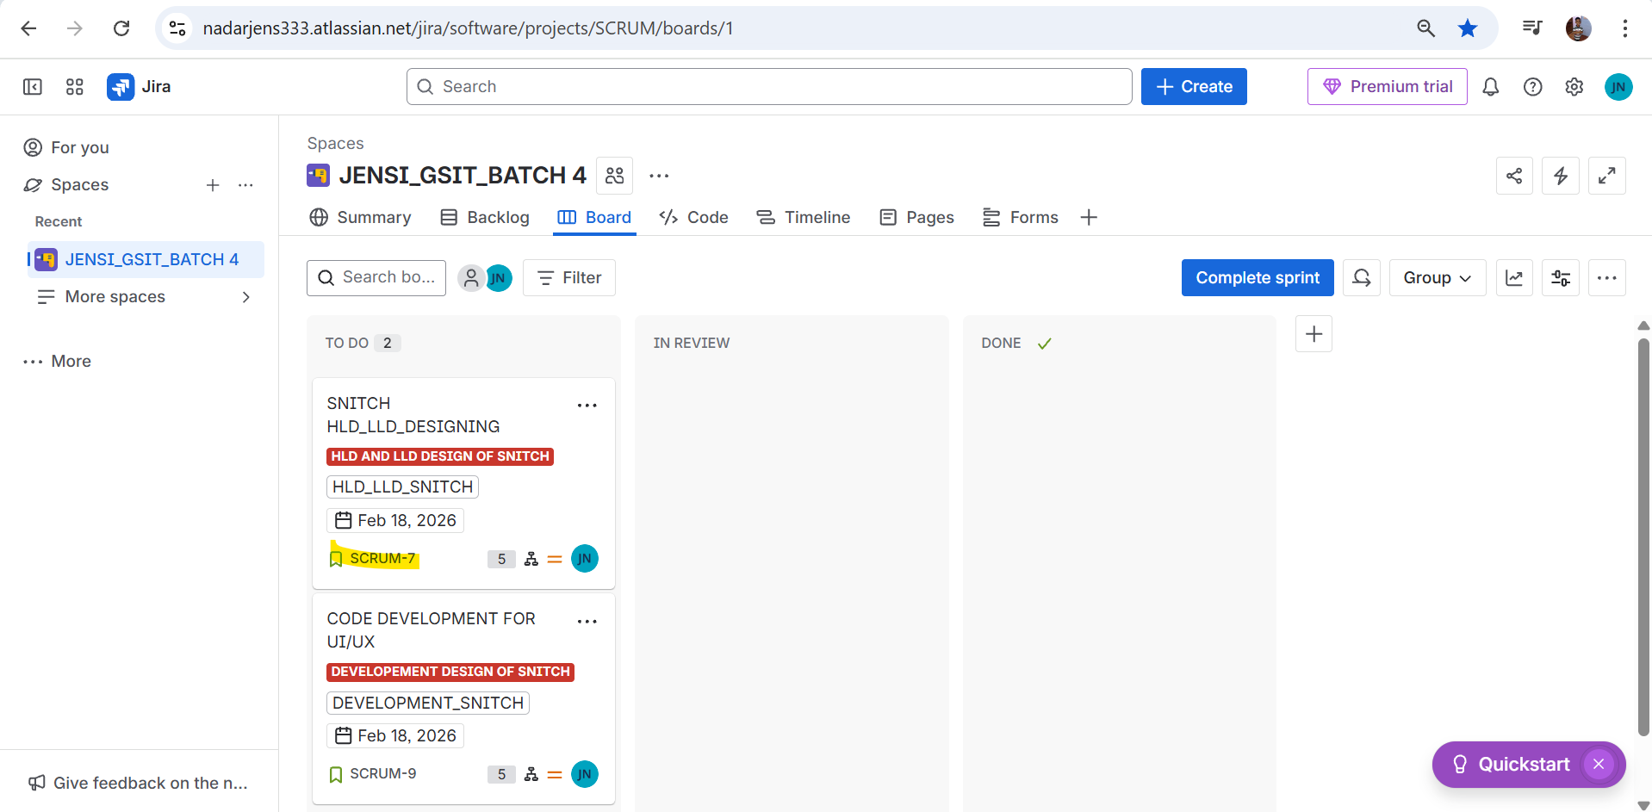

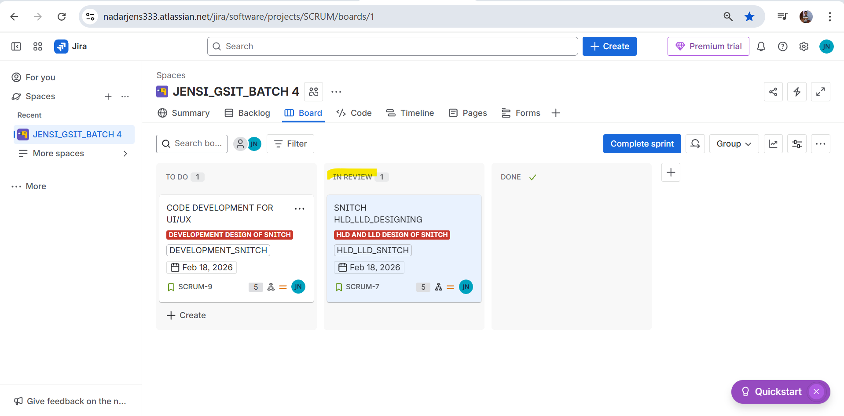

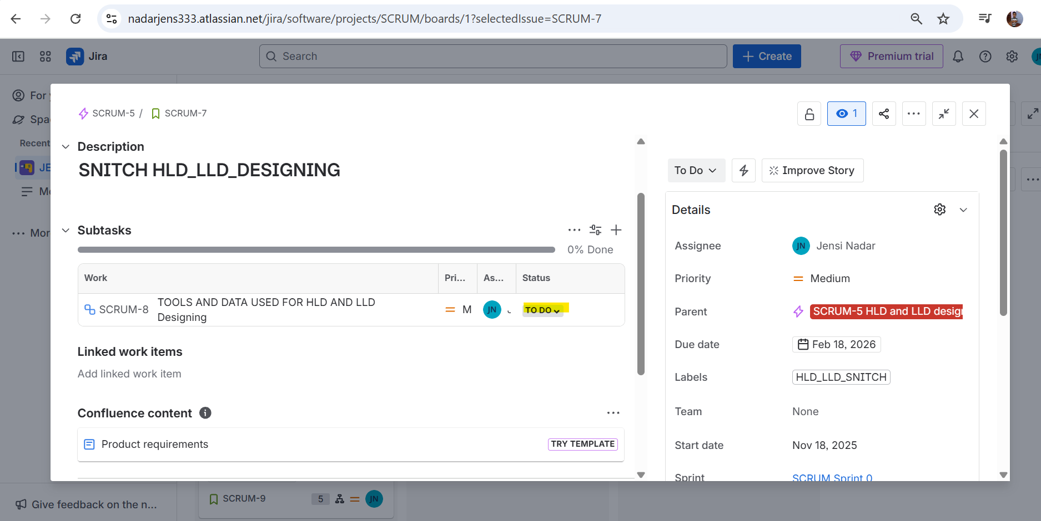



1. **Creation of BUG**

* **Click on Create button**
* **Select work type as BUG**

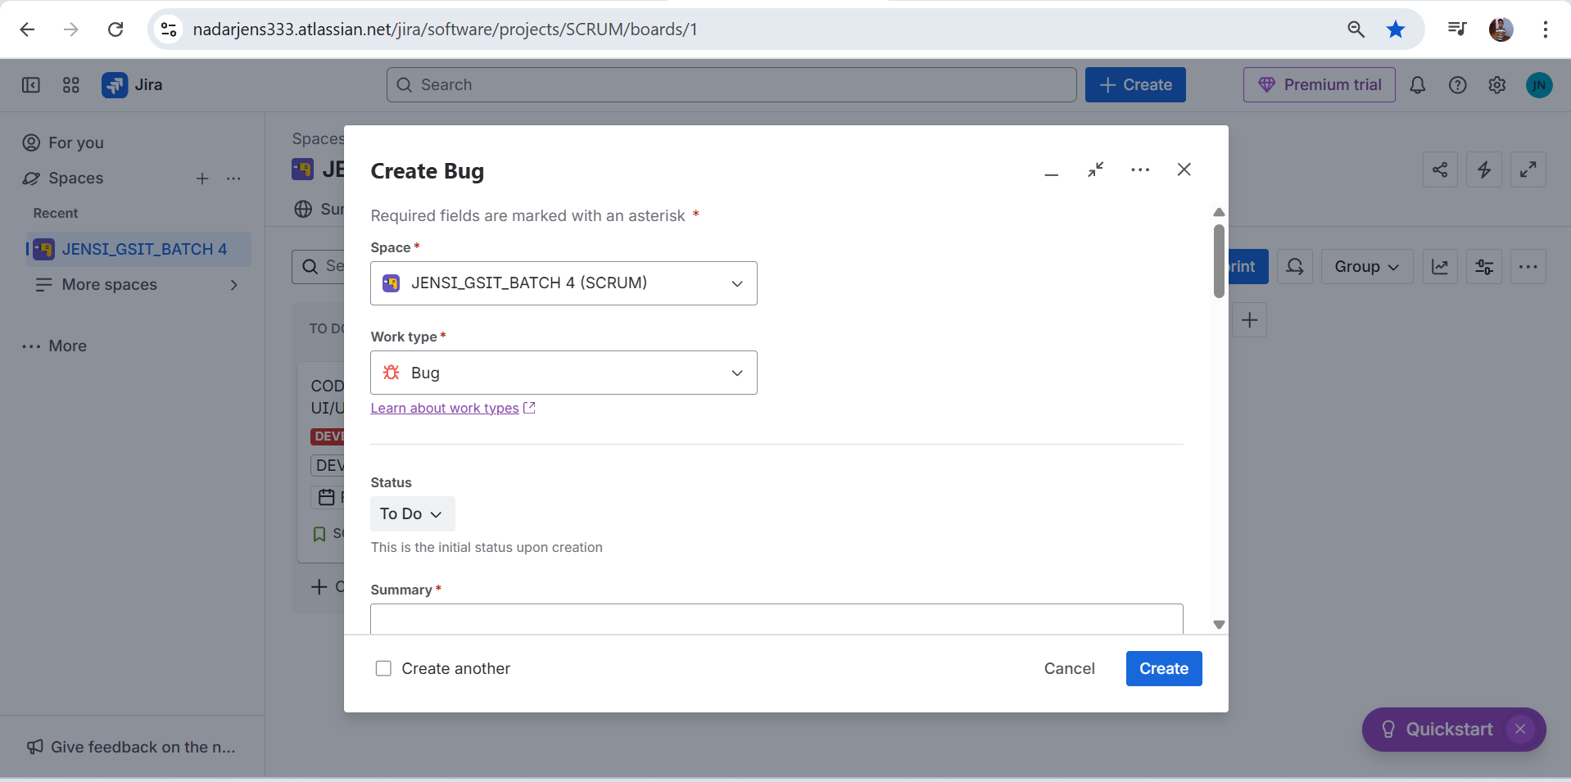

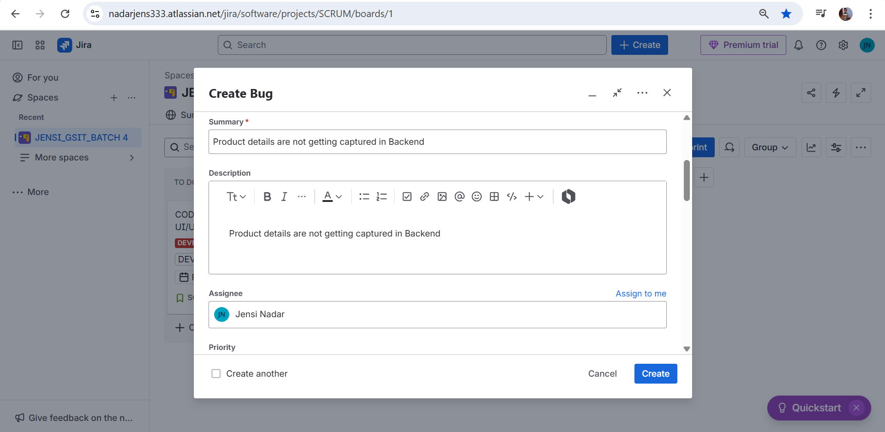

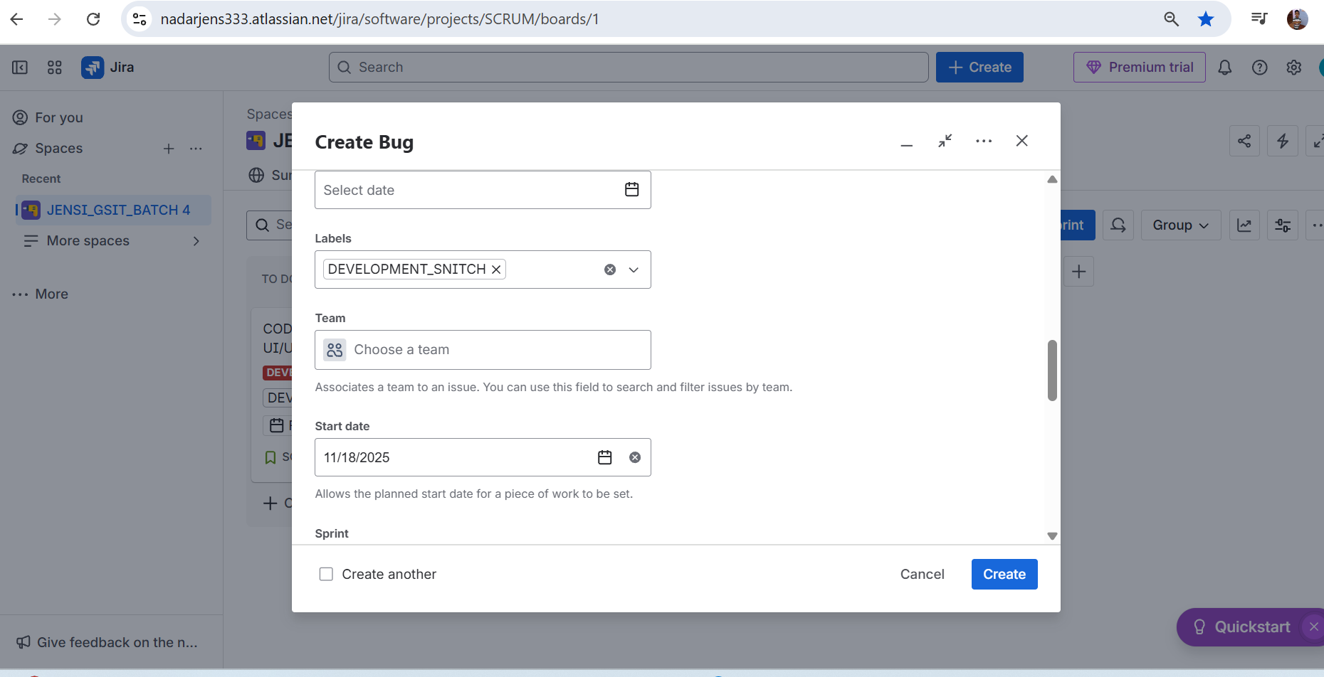

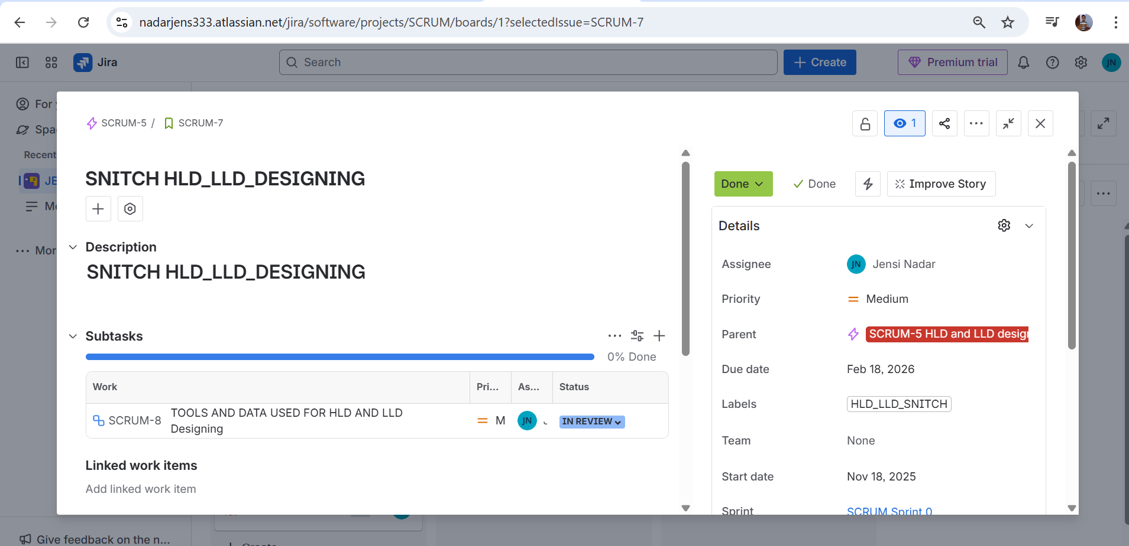

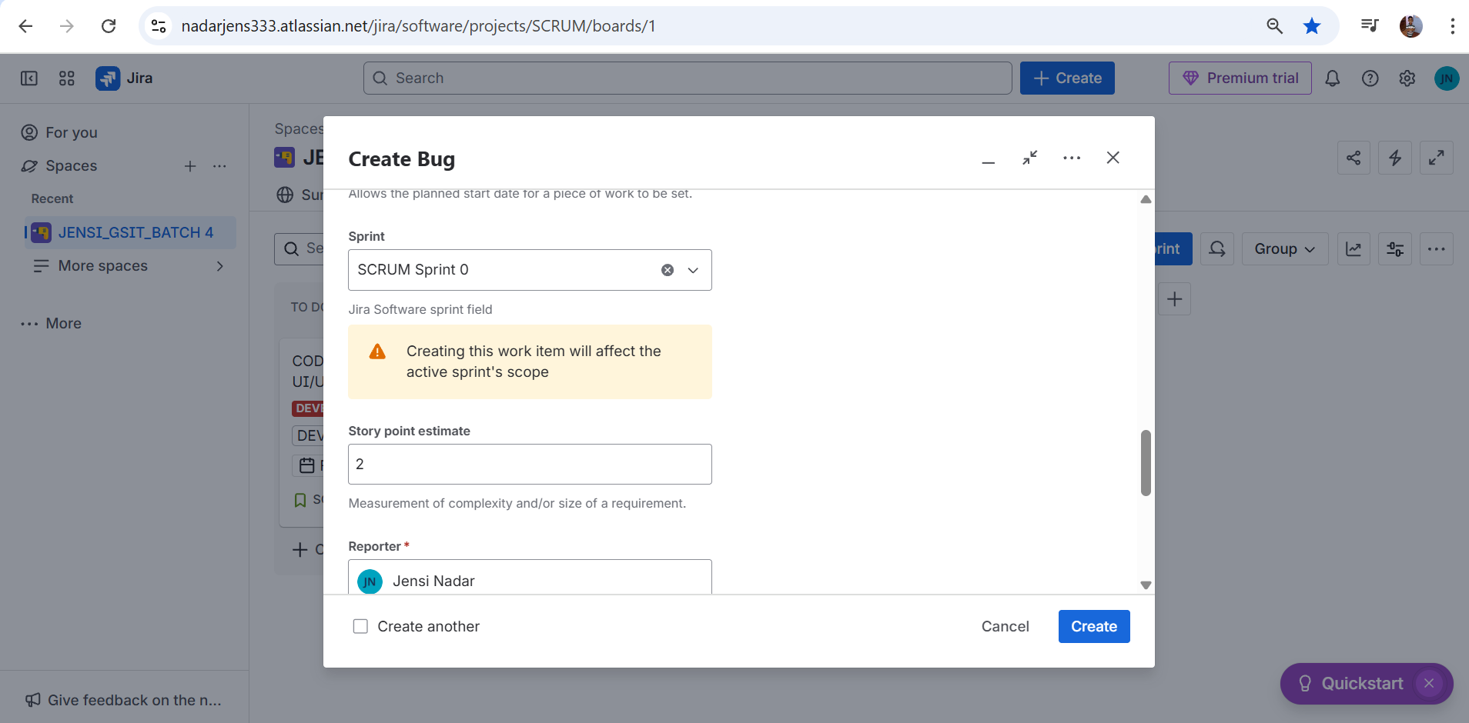

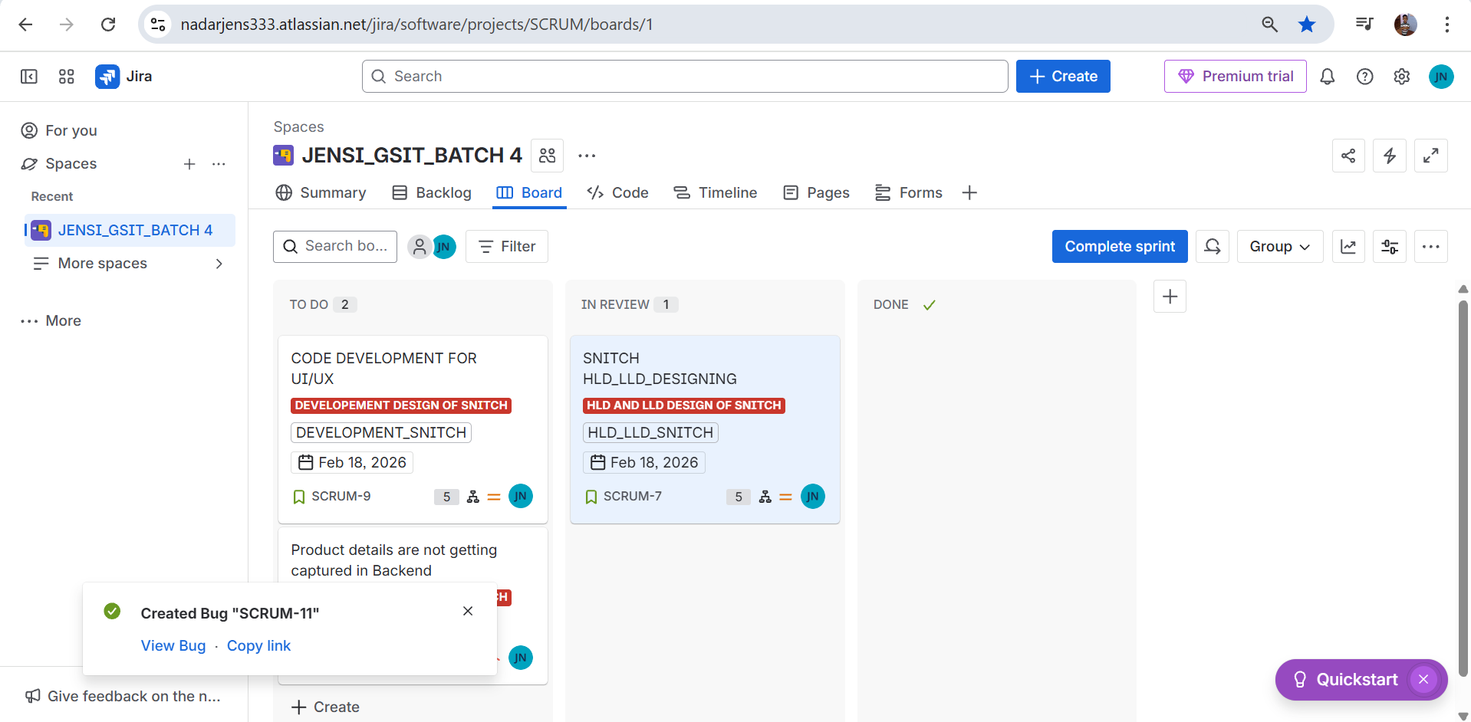

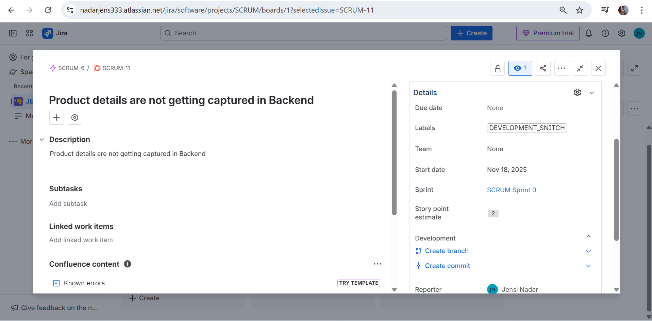

1. **Complete the user story**



